Walker Bay Fynbos Conservancy

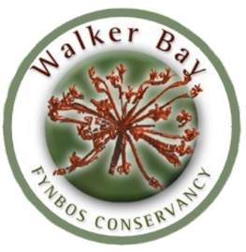

Conservation Management Plan
November 2015

Compiled by: | Compiled for: | Funded by:
Sean Privett  Lily Upton  Thilivhali Murivhami  Francis Martens  Chris Groenewald | Walker Bay Fynbos Conservancy | Grootbos Foundation

Contents

PART I 4
1. INTRODUCTION 4
1.1 LOCALITY 7
1.2 AREA SIZE AND MEMBERSHIP 7
➢ CLIMATE 11
➢ GEOLOGY 11
➢ VEGETATION 11
➢ CONSERVANCY PLANT LIST 14
1.4 SOCIAL AND CULTURAL ATTRIBUTES 17
➢ RECREATIONAL 17
PROPERTY DESCRIPTIONS 18
❖ Bellavista 18
❖ Bodhi Khaya 18
❖ Farm215 19
❖ Fynbos Retreat 19
❖ Grootbos Private Nature Reserve 19
❖ Mosaic Private Sanctuary 19
❖ Witkrans 20
❖ Wortelgat 20
➢ EDUCATIONAL 20
❖ The Flower Valley Conservation Trust 20
❖ Grootbos Foundation 20
❖ Skills Exhange Cooperative 21
❖ Fynbos Trail 21
1.5 ARCHEOLOGICAL 21
1.6 HISTORICAL 22
1.7 LEGAL STATUS 22
➢ CONSERVANCY 22
➢ LOCAL NATURE RESERVES 22
➢ PRIVATE NATURE RESERVES 22
1.8 THREATS 22
➢ AREA SENSITIVITY 22
➢ UNTIMELY FIRES 23
➢ INVASIVE ALIEN VEGETATION 23
➢ INAPPROPRIATE DEVELOPMENT 23
2.1 MANAGEMENT 24
➢ OBJECTIVES 24
➢ MANAGEMENT RECOMMENDATIONS 24
2.2 MANAGEMENT OF BIODIVERSITY 24
2.2.1 FIRE MANAGEMENT 25
➢ ADVANTAGES OF GOFPA MEMBERSHIP 25
➢ OBJECTIVES 25
➢ FIRE REACTION PLAN 26
2.2.2 INVASIVE ALIEN VEGETATION SPECIES 35
BACKGROUND 35
➢ OBJECTIVES 35
➢ BUDGET 36
2.2.3 FAUNA AND FLORA INVENTORIES 38
3. WALKER BAY FYNBOS CONSERVANCY WITHIN THE GREATER CONSERVATION LANDSCAPE: 38
REFERENCES 39
APPENDIX 1: WBFC Masters Certificate 40
APPENDIX 2: WBFC PLANT LIST 40
APPENDIX 3 PROVISIONAL ALIEN CLEARING PLAN 2016- 2018 62
APPENDIX 4: BEES & WASPS 64
APPENDIX 5: MOLLUSCS 65
APPENDIX 6: AMPHIBIANS 66
APPENDIX 7: REPTILES 67
APPENDIX 8: BIRDS 68
APPENDIX 9: MAMMALS 69
APPENDIX 10: WBFC FIRE UNIT RULES 70
APPENDIX 11: RELEVANT LEGISLATION 71
CONSERVATION OF AGRICULTURAL RESOURCES ACT 43 OF 1983 71
ENVIRONMENTAL MANAGEMENT: BIODIVERSITY ACT 10 OF 2004 71
NATIONAL ENVIRONMENTAL MANAGEMENT ACT 107 OF 1998 71

PART I

INTRODUCTION

The Walker Bay Fynbos Conservancy (WBFC) is a collaborative management project between 26 private and public landowners who together manage 14 880 hectares of fynbos and forest on the western seaboard of the Agulhas Plain

The WBFC is situated on the Western Agulhas Plain, in an area of remarkable biodiversity, which at latest count provides a home for:
- 22 amphibians
- 46 reptiles
- 24 molluscs
- 38 bees and wasps
- 106 bird species
- 30 mammal species
- 989 plant species,
- 111 of which are of conservation concern and
- 6 of which are new to science
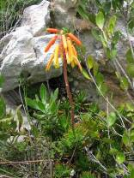
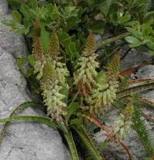
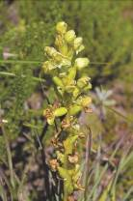
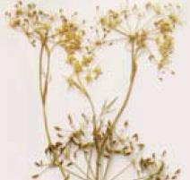
- 8 of which are endemic
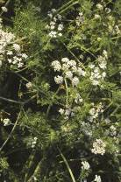
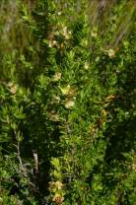
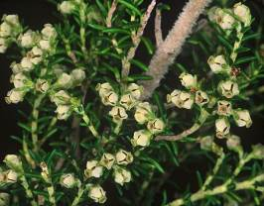
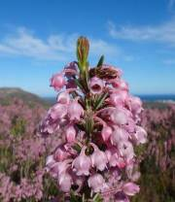
Plants endemic to the Conservancy: Top row: Left to Right: Aloe judii, Dasispermum grandicarpum, Lachenalia lutzeyeri, Pterygodium vermiferum; Bottom row: Left to Right: Capnophyllum lutzeyeri, Erica magnisylvae, Cliffortia anthospermoides and Erica irregularis

The WBFC covers a wide variety of vegetation types: (see figure 1)
- Overberg sandstone fynbos – critically endangered (3 526.4 hectares 24%)
- Elim ferricrete fynbos – critically endangered (574 hectares – 4%)
- Milkwood thicket – endangered (60 hectares – 0.004%) (not shown on chart)
- Agulhas limestone fynbos – vulnerable (4 015 hectares – 28%)
- Overberg dune strandveld – least threatened (6 023 hectares 42%)
- Southern Coastal Forest – vulnerable (129 hectares – 1%)
- Western Coastal Shale Band Vegetation - least threatened (79 hectares – 1%)
- Wetland (not measured) –
- Afromontane forest (not measured)
- Cape Estuarine salt marshes (not measured)

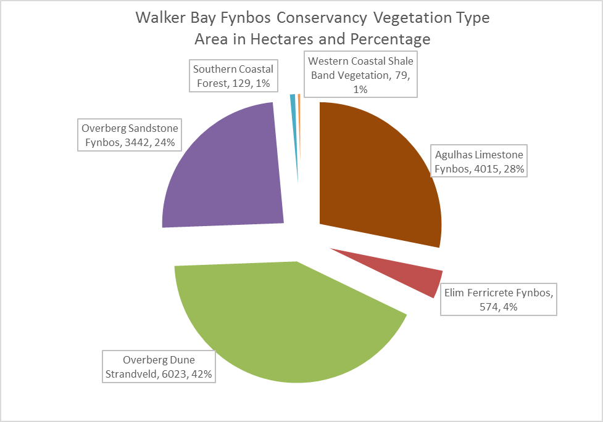
Figure 1 Major vegetation types of the WBFC

This Plan, the third version produced by WBFC, has been developed for the landowners of the Walker Bay Fynbos Conservancy (WBFC). It is the result of several meeting with the Conservancy members at formally constituted Conservancy meetings as well as other meeting and conversations with the various owners. It has been developed as an update on two previous conservancy management plans compiled in 2001 (Privett and Kotze 2001) and 2008 (Davies 2008)

The aim of the management plan is to provide a single co-operative plan for all landowners within the conservancy to use for management purposes. This document should also provide the basis on which annual plans of action and budgets for the next three years (2015-2018) are developed. The Agulhas Plain, of which the Walker Bay Fynbos Conservancy is part, has been recognised as a high priority area for future conservation initiatives by the CAPE project. The need to develop public/private conservation partnerships and innovative models for conservation outside of state reserves was also emphasised by the project.

The Walker Bay Fynbos Conservancy (WBFC) was founded on the 10th of December 1999. A conservancy is defined as a group of properties in which neighbours have pooled their resources for the purpose of conserving the fauna and flora, as well as the adoption of environmentally friendly land use practices.
BACKGROUND INFORMATION

This management plan has been developed as a guideline for the future management of the conservancy. It is a draft document that will be updated as the various conservancy initiatives progress. It is hoped that the Walker Bay Fynbos Conservancy can continue to be a role model for collaborative public-private conservation management in the Cape Floral Kingdom.

In the mid 1990’s, a group of concerned landowners in the Walker Bay area initiated the process that led to the formation of the Walker Bay Fynbos Conservancy. The conservancy developed out of the realisation by landowners that their properties fall within a natural area of considerable conservation value. Their properties were being threatened by invasive alien vegetation and repeated uncontrollable wild fires. They also saw the threats posed by irresponsible developers and new agricultural land-use practices in the region. In 1999, a number of meetings were held to which interested and concerned landowners were invited, which led to the formation of the Walker Bay Fynbos Conservancy. Initially, 11 landowners signed up to the new conservancy. A subsequent 15 landowners have joined, making up the current membership of 26 landowners (see Table 1).

Since its registration in December 1999 the WBFC has established itself as a committed and forward thinking conservation group. Custodians to an amazing diversity of flora and fauna, the members have set about securing the long-term conservation status of the area. In a relatively short time the conservancy has developed its own constitution and established a Trust (IT 1443/2004).

In 2000, the conservancy was granted R100 000 by the South African government’s Working for Water Program to use towards the removal of exotic vegetation and job creation in the area. At the 2001 Whitley Awards in London, the Walker Bay Fynbos Conservancy was awarded the twenty thousand pound Iris Darnton Award for International Nature Conservation. This is the most prestigious plant conservation award in the world (www.whitleyaward.org).

More recently, in an effort to streamline the financial processes, the number of trustees was reduced to five of the original eleven, with changes to the conservancy trust document approved by the Master of the high court on the 20th of May, 2014.

The Conservancy is managed by the Trustees and a Committee, which is made up of landowners who are elected at the Annual General Meeting. The Committee is headed by the Chairperson and meets at least four times a year. The members each pay a subscription fee, which helps to cover the administrative costs.

The conservancy is well established and is highly regarded by conservationists both locally and abroad, with more information available on our website www.fynbos.co.za. The purpose of the plan is to provide a solid framework for decision making, and for the future management of the conservancy. It is the intention of the conservancy to employ a conservation manager who will implement this plan, using it as a working document and ultimately to protect the region’s unique biodiversity, create new opportunities for employment and enhance economic activity in the area. The Grootbos Foundation (www.grootbosfoundation.org) has funded this version of the Management Plan.

In February 2006, a wildfire swept through the Agulhas Plain, destroying approximately 60 000 hectares, and in its wake almost all of the Conservancy was burnt. This wildfire swept through the area, destroying properties which included one of the Grootbos lodges. It did, however, present an opportunity to deal with the invasive alien plant problem. Significant funding has been obtained by the Conservancy to deal with the re-sprouting and any new seedlings after the fire.

Between 2013 and 2015, in excess of R1 million per annum has been sourced by the Conservancy for alien vegetation clearing as part of the ABI alien clearing programme funded by the Department of Environmental Affairs. A manager has been employed to supervise this project and more than 6 000 hectares of alien vegetation have been cleared during this time.

Plans beyond 2015 include appointing a full time conservation manager to oversee current and future projects within the WBFC conservation area.

LOCALITY

The WBFC is roughly rectangular in shape and is situated between the towns of Hermanus, Stanford and De Kelders in the Overberg district of the Western Cape Province in South Africa. The locality of the conservancy and its surrounds are depicted in Figure 1 and 2. The WBFC is situated at 34°32'30"S and 19°24'50"E. The details of the conservancy members are shown in Table 1 below, and Figure 2 shows the property location of these individual members.

AREA SIZE AND MEMBERSHIP

At the time of the compilation of this management plan the total area of the conservancy was approximately 14 880 hectares. Further properties may be added to the conservancy on application. The members of the WBFC will decide on whether new properties are accepted. The members’ properties as at December 2015 are showed in Figure 2 below.

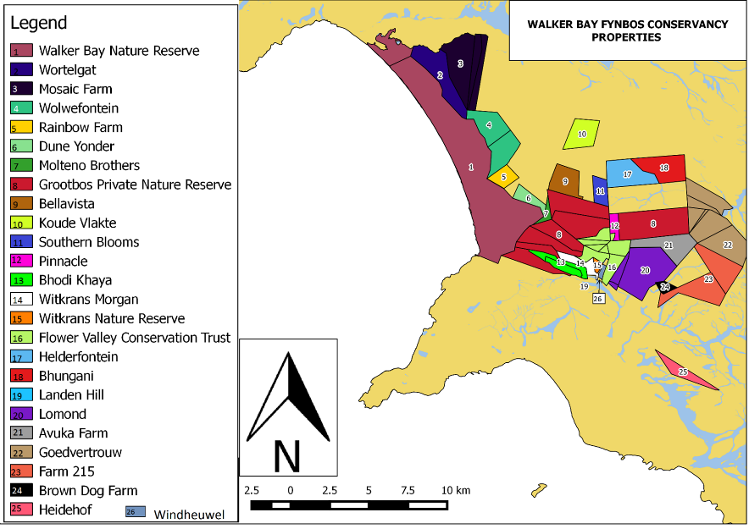
Figure 2 Walker Bay Fynbos Conservancy Properties
Table 1 Members of the WBFC (December 2015)
MAP NO | FARM NAME | CONTACT PERSON | CONTACT N0. | EMAIL AND WEBSITE
1 | Walker Bay Nature Reserve (Cape Nature) | Deon Geldenhuys | T. 028 314 0062  C. 082 496 3395 | dgeldenhuys@capenature.co.za  http://www.capenature.co.za/reserves.htm?reserve=Walker+Bay+Nature+Reserve
2 | Wortelgat (See-Eike Trust) | David Hofmeyr | C.082 771 6660 | dgmhofmeyr@gmail.com
 |  | Marius Boucher | T. 028 3410666
 |  |  | C. 082 7716660
3 | Mosaic Farm | Breese & Kathryn Johnson | T. 028 313 2814 | info@mosaicfarm.net
 |  |  | C. 082 825 3211 | kathryn@mosaicsouthafrica.com
 |  |  |  | breesej@bellsouth.net
 |  | Marcelino Henckert |  | marcelino@mosaicsouthafrica.com
 |  |  |  | www.mosaicsouthafrica.com
4 | Wolwefontein Private Nature Reserve | Italo & Dulcie Martinengo | W. 028 384 0086 | italo@gamco-sa.co.za
 |  |  | H. 028 384 1045 | dulciem@vodamail.co.za
 |  |  | C. 082 326 3904
 |  |  | F. 028 384 0086
5 | Rainbow Private Nature Reserve | Lutz & Karin Kettner | T. 028 312 3461 | Lutz.kettner@itec.co.za
 |  |  | F. 028 312 4087
6 | Dune Yonder | Val & Tim Deverson |  | deverson.valandtim@gmail.com
7 | Molteno Brothers Trust | Ian Moodie | T. 021 859 2527 | info@moltenobros.co.za
 |  |  | F. 021 859 4893 | imm@moltenobros.co.za
8 | Grootbos Private Nature Reserve | Sean Privett | T. 028 384 8048 | sean@privett.co.za
 |  |  | C. 082 4111 008
 |  | Michael/Tertius Lutzeyer | F. 028 384 8100 | tertius@grootbos.co.za
 |  |  | T. 028 384 8000/1
 |  |  | F. 028 384 8042 | www.grootbos.com
9 | Bellavista | Georges Schwegler | T. 028 341 0178 | bellavista@hermanus.co.za
 | (Waterkop) |  | C. 082 901 7650 | www.bella.co.za
 |  |  | F. 028 341 0170
10 | Koude Vlakte | Simon & Shawn Graaff | H. 021 882 8701 | Simon.graaff@gmail.
 |  |  | C. 073 315 6027 | shawngraaff@gmail.com

11 | Southern Blooms | Robert Fraser | T. 021 422 0635  C. 083 310 1930 | fraser.bank@gmail.com
 |  | Henrietta Hamilton |  | hvhamilton@gmail.com
12 | Pinnacle | Dominic van Schouwen | C. 082 331 3962 | dvanschouwen@gmail.com
13 | Bodhi Kaya | Georgina Hamilton | T. 028 388 0156 | info@bkr.co.za
 |  |  | F. 028 388 0177 | www.bodhi-khaya.co.za
 |  | Warren Stegmann |  | warrenstegmann@me.com
14 | Witkrans (698) | Rod Morgan | T (011) 656-9889 | mkaya@iafrica.com
 |  |  | C 083-267-4137
 |  |  | F (011) 802-2465
15 | Witkrans (697/1) | Sean & Michelle Privett | C. 082 4111 008 | sean@privett.co.za
 |  |  | C. 082 464 5115 | michelle@privett.co.za
 |  |  |  | www.witkrans.com
16 | Flower Valley | Lesley Richardson | T. 028 425 2218 | lesley@flowervalley.co.za
 |  |  | F. 028 425 2855
 | Conservation | Roger Bailey | C. 082 329 0246 | rbailey@flowervalley.co.za
 | Trust |  | T. 028 388 0713 | www.flowervalley.org.za
17 | Helderfontein | Amanda Botha | T. 021 887 2209 | atheo.botha@gmail.com
 |  |  | M. 081 270 1556
 |  |  | F. 021 808 3607
18 | Bhungani Farm | Anthony & Angela Wain | H. 021 794 3402 | awain@mweb.co.za
 |  |  | F. 021 418 0510
 |  |  | C. 082 455 3291
19 | Landen Hill | Eddie & Silvana Burger | T. 028 388 0983 | silvana@burmar.co.za
 |  |  | C. 083 2704 808 | eddie@burmar.co.za
20 | Lomond Wine Estate | Wayne Gabb | T. 028 388 0095 | wayne@biogrow.co.za
 |  |  | F. 028 388 0130 | www.lomond.co.za
21 | Avoka | Alwyn Naude | C. 076 653 4572
22 | Goedvertrouw | Danie & May de Villiers | T. 028 388 0272 | djj.devilliers@gmail.com
 |  |  | F. 086 607 1946
 |  |  | C. 082 554 1762
23 | Farm 215 | Maarten Groos | T. 028 388 0920 | maarten@farm215.co.za
 |  |  | C. 082 097 1655 | www.farm215.co.za
24 | Brown Dog Farm | Trevor Penney | T: 082 667 9232 | trevorpenney@gmail.com
 |  | Annett Schirmer
25 | Heidehof Private | Mathia & Walter | T. 028 388 0073 | schwegler@telkomsa.net
 | Nature Reserve | Schwegler | C. 082 901 5070 (Walter)
 |  |  | C. 072 798 7181 (Mathia)
26 | Windheuwel | Franz Birkholtz | T. 012 644 2641 | fbirkholtz@gmail.com
 |  |  | C. 082 929 8043

1.3 ENVIRONMENTAL CHARACTERISTICS

CLIMATE
The WBFC falls within the winter rainfall region of the Western Cape. May to August are the wettest months, and the summers are hot and dry (figure 3). The orographic features of the area profoundly influence the precipitation. Average annual rainfall at the closest long-term weather station (Danger Point lighthouse, 10 km south) is approximately 500 mm and that of Grootbos and Lomond are approximately 730 mm (1996-1999) and 727 mm (2000-2012) respectively. Mean maximum daily temperature is lowest during July (± 14°C) and highest during February (± 25°C). The prevailing wind in summer is the south-easter, which often reaches gale force. In winter the prevailing wind is the north-wester. This is the dominant rain carrying wind. The area is frost free, hail is rare and thunderstorms very occasional.

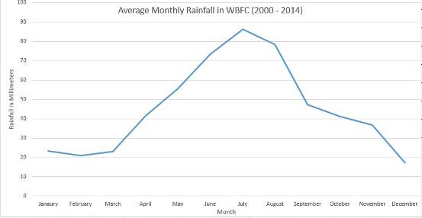
Figure 3 Rainfall data received from Lomond Wine Estate

GEOLOGY

The basic geological structure of the WBFC consist of a sloping landscape created primarily by low quartzitic sandstone ranges of the Cape Fold Belt rising to 514 m above mean sea level (amsl). The underlying rock is Table Mountain Sandstone. A number of formations overlay this base. Predominant is the deep covering of aeolian sand on the lower slopes. Other formations include Bredasdorp limestone and ferricrete. There are patches of rich organic soils in seepage zones and valley bottoms

As one moves from lower to higher altitude in the conservancy, the general surface-level geological sequence is one of aeolian sands, followed by shallow limestone deposits and then Table Mountain Sandstone with patches of ferricrete.

VEGETATION

The WBFC falls within the Cape Floristic Kingdom (Good 1974, Takhtajan 1986), which is known to have approximately 9 000 vascular plant species in an area of about 90 000 km² (Goldblatt and Manning 2000). Of these plant species, 3 185 are on the red data list and of conservation concern (Raimondo et al 2009). More than one-third of the original area occupied by fynbos has already been lost to agriculture, development, forestry and invasive alien species.
One of the early objectives of the conservancy was to document its major plant communities. A thorough field survey of the WBFC supplemented by satellite imagery was used to achieve this. In addition, the vegetation of the WBFC has been described and mapped by various field workers in the past, these include Acocks, 1988; Cowling RM, Campbell BM, Mustart P, McDonald DJ, Jarman ML, Moll EJ; 1988; D Euston Brown (1999 and 2005); Cole NS, Lombard AT, Cowling RM, Euston-Brown DIW, Richardson DM & Heijnis CE (2000) and Mucina L & Rutherford MC 2006. Each of these has dealt with the area in varying levels of detail. However the latest study was that undertaken by D Euston Brown (2007) see figure 4
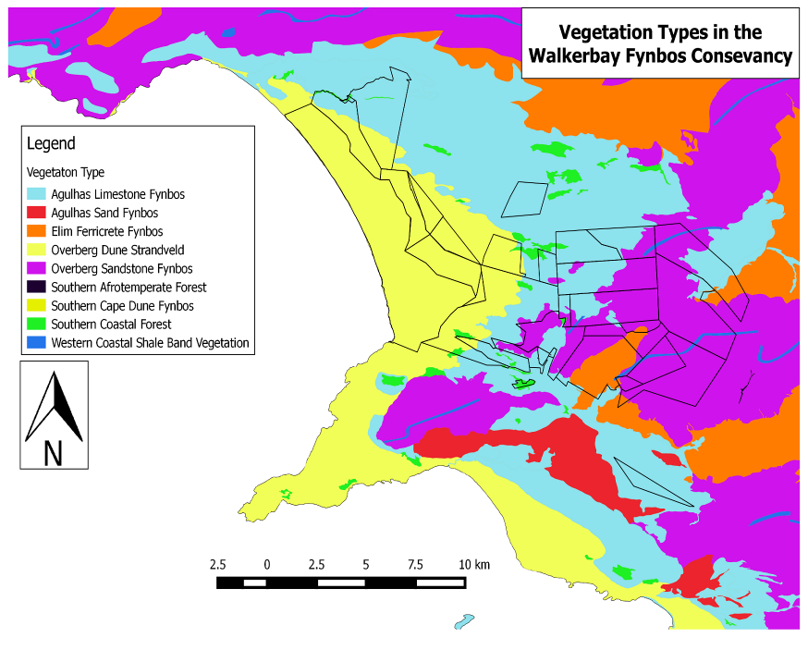

WALKER BAY FYNBOS CONSERVANCY:
VEGETATION TYPES
Figure 4 Vegetation types of the WBFC
Table 2. Main Vegetation Types Within The Walker Bay Fynbos Conservancy
VEGETATION  TYPE | AREA | RED DATA STATUS | DESCRIPTION
Overberg Sandstone Fynbos |  | Critically endangered | Overberg sandstone fynbos is found on exposed, rocky Table Mountain sandstone spread irregularly on the lower mountain ranges between Bot River in the west and the Soetanysberg and Bredasdorp in the east. This vegetation type has been re-classified as critically endangered owing to the very high number of threatened species. It can be structurally classified as a low to medium, dense proteoid layer that is usually less than 1.5m high. There is usually no clear dominance of one species but Mimetes cucullatus and Leucadendron salignum are the most common, joined by Aulax umbellata, Leucadendron tinctum, Leucadendron spissifolium, Leucadendron xanthoconus, Protea acaulos, Protea cyneroides, Protea longifolia and Protea speciosa.
Southern Coastal Forest |  | Vulnerable | These forests occur from the Western Cape to the Eastern Cape provinces. The westernmost forest type of this group consists of Western Cape Milkwood forest, which stretches along the southern seaboard from Nature’s Valle to Llandudno, Cape Town.  These low forests are dominated by Sideroxylon inerme, Celtis africana, Mimusops caffra and Dovyalis rotundifolia. They occur on well drained, sandy soils along the coast.
Western Coastal Shale Band Vegetation |  | Least Threatened | This vegetation type is found within the mountain ranges in the Western Cape, extending into the Kleinrivierberge, Caledon Swartberg & Bredasdorpberge, the Riviersonderend Mountains and Potberg in the Overberg. This vegetation type supports diverse renosterveld and fynbos shrublands of all structural types. This vegetation type occurs on clays derived from shale of the Cederberg formation. The Potberg shale band includes species of Protea aurea and Protea coronata. These shale bands often support small patches of Afromontane forest in gullies and on saddles.
Western Cape Milkwood Forest |  | Endangered | The Western Cape Milkwood Forests have recently been classified as endangered due to their small geographic extent and high level of threats. Four large patches are present at Tygerboom, Grootbos, Steynsbos and Witvoetskloof. 60 hectares of milkwood forest are present on Grootbos. White Milkwood (Sideroxylon inerme), is widespread in coastal forests and thickets along the southern and eastern coastline of South Africa, but this type of forest is restricted to the Stanford Gansbaai area, with the only protected patches being on Grootbos.  Droguertia iners dominates in most places and is accompanied by the grass Ehrharta erecta. The only true shrub species within full shade of the forest is Myrsine africana. Climbers which occur include Asparagus aethiopicus, Cynanchum obtusifolium, Kedostris nana and Zehneria scabra.

CONSERVANCY PLANT LIST

A total of 989 plant species have been recorded within the Conservancy. Of these 124 are categorised as species of conservation concern and 8 are endemic. A complete plant list has been included at the end the management plan as Appendix 2

The conservancy has a total of 111 Red Data Species (Raimondo etal 2009). There are a total of 1 critical endangered, 25 endangered, 7 rare, 29 Near Threatened, 5 declining, and 44 Vulnerable

- SOILS

The soils within the Conservancy are generally sandy and/or shallow and generally poor and not suited to agriculture. Figure 4 below is extracted from the SANBI website (www.bgis.sanbi.org), together with the description of their characteristics.

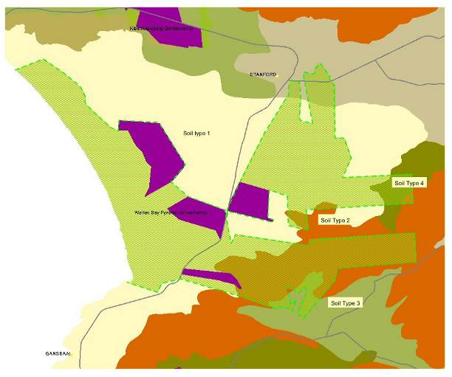

Figure 5: Soil Types within the Walker Bay Fynbos Conservancy, as described at www.bgis.sanbi.org.

There are three major soil types within the Conservancy. Those closer to the coast (Soil Type 1), which comprise most of the soils, can be described as ‘imperfectly drained sandy soils’, they may have favourable water-holding properties and but are also highly erodible. The soils further east (Soil Type 2), into the hills, are described as water catchment areas and have limited land use options. The better soils are those to the extreme south east (Soil Type 3) of the Conservancy which show higher agricultural potential. They are described as follows, “may have favourable physical properties, somewhat high natural fertility; relative wetness favourable in dry areas. Their limitations may include restricted depth, imperfect drainage, high erodibility; slow water infiltration and seasonal wetness. Finally a small pocket in the north western corner (Soil Type 4) are described as follows: “relative wetness favourable in dry areas but may be limited due to being seasonally wet, they are classified as imperfectly drained soils, often shallow and often with a plinthic horizon’.
These soil types suggest a low agricultural potential, except perhaps for the better soils in the extreme south eastern edge of the Conservancy. It is recognised that the soils are mapped at a very broad scale and there may be pockets of better soils in some areas.

FAUNA

Being typical of Fynbos vegetation regions, the WBFC has low mammal species occurrence. The variety of vegetation communities however, provides habitats for many invertebrate species. Reptiles and birds are also well represented in the area. The fynbos is renowned for its plant-animal interactions, with many species dependent on each other for their survival. Pollination and seed dispersal of many plant species are intricately linked to their faunal partners. The correct management and conservation of the faunal aspects of the conservancy is therefore imperative to the future functioning of the ecosystems making up the biological component of the conservancy.

In 2015 the WBFC acquired eight camera traps (funded by Grootbos Nature Reserve) and a comprehensive faunal survey was initiated. For the purpose of this management plan, a faunal species list was taken from the Animal Demography Units Virtual Museum (http://vmus.adu.org.za/) from the University of Cape Town. This will be updated using results from our inhouse survey in future management plans.
The fauna of the conservancy has been divided into six major categories: invertebrates (bees and wasps; mollusks), fish, amphibians, reptiles, birds and mammals. Species lists of all animals collected or sited for all categories can be found at the end of this document, as Appendices.
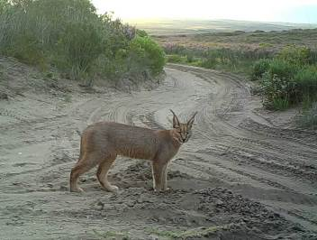
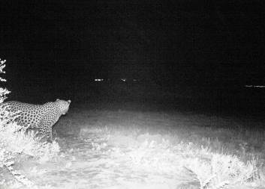

A caracal and leopard captured on Grootbos Nature Reserve, June 2015

Invertebrates

Invertebrates, such as insects, spiders, scorpions, and molluscs are the most numerous of all the fauna found in the fynbos. Insects play a very important role in pollinating many of the fynbos flowers. Beetles, flies, bees, moths, and butterflies are the main pollinators although other insects such as earwigs, wasps and thrips also play a role. Of particular importance is seed dispersal by ants (myrmecochory), particularly the pugnacious ant. (Appendix 4. Bees & Wasps; Appendix 5 Molluscs)

Fish

The WBFC is generally a very dry landscape with few permanent water bodies. There are dams stocked with exotic fish (trout and bass, for example) on some of the farms. The Klein River Lagoon falls just outside of the conservancy boundary and is a very important estuary for a number of marine fish species.

Amphibians

Twenty-two species of amphibia have been recorded in the conservancy thus far. Five red data list species has been recorded in the area: the western leopard toad (Amietophrynus pantherinus) the cape platanna (Xenopus gili), the micro frog (Microbatrachella capensis), the marsh frog (Poyntonia paludicola) and the Rose’s toadlet (Capensibufo rosei). The conservancy should aim to submit data for the frog atlas project (Appendix 6)

Reptiles

Forty-six species of reptiles, occurring in all the major habitat types, have been recorded in the WBFC. Puff adders, Cape Cobras, mole snakes, harlequin snakes, blind snakes and angulate tortoises are some of the reptiles that live in the sandy areas. Dense forest provides a perfect environment for the boomslang and rocky areas provide hiding and basking places for most reptiles, especially lizards. (Appendix 7)

Birds

There is not a high diversity of birds in the fynbos. Although about 100 species (excluding seabirds) have been recorded in the fynbos region, most of them are not associated specifically with fynbos.

The WBFC bird species list of 106 species incorporates comprehensive lists from Grootbos Nature Reserve. Birds play an important role in the pollination of many species of Protea (sugarbirds) and Erica (sunbirds) as well as other species. Birds also play an important role in seed dispersal, especially of forest and thicket species. (Appendix 8)

Mammals

The last few centuries have seen a dramatic decline and mass extinction of many of the indigenous animals found in the conservancy and its surrounds. The African elephant reached the Cape Peninsula and Agulhas. Elephant tusks have been found within the conservancy at Witvoetskloof. A leopard jaw bone has been found in the dunes of the Walker Bay Nature Reserve (WBNR). Hippopotamus, black rhinoceros, eland and hartebeest were all once found in the conservancy. These animals were hunted by the San bushmen but at levels that enabled them to persist. Khoi-Khoi sheep and cattle had partly replaced African buffalo and bontebok about 1 700 years before European settlement. However it was the arrival of the Europeans that resulted in the rapid extinction of large mammals from the region.

A preliminary list of mammals has been compiled for the conservancy (Appendix 9). Twenty nine mammal species are believed to occur on the WBFC according to the ADU Virtual Museum.
It has been proposed that the conservancy could potentially re-introduce game in the future. The following is a list of species which are either already present at low numbers, or species that used to occur in the area and that could potentially be re-introduced: (species present are indicated with *)

Bush buck* Klipspringer*
Steenbok* Cape Grysbok*
Common Duiker* Caracal*
Aardwolf* Grey Rhebok*
Bat-eared Fox* Red Hartebeest
Bontebok Cape Buffalo
Cape Mountain Zebra Eland*

Fynbos has a very low grazing potential and therefore the carrying capacity for game has always been low. Statistics relating to carrying capacity in fynbos are misleading as the nutritional value of fynbos varies considerably depending on the vegetation type and age. It is imperative that the conservancy management concentrate on proper veld management, as discussed in this management plan, and only use carrying capacity statistics as guidelines. Experience from Fair Hill Private Nature Reserve suggests that mineral deficiencies are the major factor limiting carrying capacity of game in the area. While Ostriches and Eland, which are browsers, have been successfully re-introduced into a relatively small fenced area (500 hectares), the Wildebeest, which used to occur in the area all died due to a lack of grazing. According to Toni Milewski, a well-known biologist, Cobalt is the major limiting mineral in the coastal asteraceous vegetation found at Fair Hill. By providing the Eland with a Cobalt lick, the owners of Fair Hill found that the animals’ condition improved. Further game introductions should take careful cognisance of vegetation type, variety and age. The conservancy includes a wide variety of habitats including previously cultivated areas which could provide ample food for both grazers and browsers. (Appendix 7)

1.4 SOCIAL AND CULTURAL ATTRIBUTES

RECREATIONAL

The majority of privately owned properties within the conservancy are used by their owners for their own recreation. Over the last twenty years the profile of the landowner within the area that now makes up the conservancy has changed dramatically. The traditional livestock and flower farmers who heavily exploited the natural resources of their properties have been replaced by more affluent landowners with a stronger environmental bias. The majority of the present landowners are either foreigners or South Africans who have moved from the city for nature and space. A number of members are nature enthusiasts who enjoy walking on their properties, bird watching and collecting and identifying plant species.

The state owned Walker Bay Nature Reserve has the highest level of recreational activity within the conservancy. Fishermen, 4X4 enthusiasts, swimmers and surfers make use of this coastal strip. Visitation increases dramatically over the holiday season and over weekends.
Over the last few years the klipgat cave enterpretation and access has been upgraded making this a feature of the reserve

An important aspect of the conservancy development is to promote the various accommodation facilities through marketing the area as a whole. A strategy should be developed to ensure that accommodation facilities work together and pass on business to each other when full.

The following properties provide accommodation:

Name | Accommodation type | Maximum number of guests | Contact Details  (telephone, email, website)
Bella vista | Luxury | 12 | www.bella.co.za  bellavista@hermanus.co.za  082 901 7650
Bodhi Khaya | Retreat & self- catering | 45 | www.bodhi-khaya.co.za  info@bkr.co.za  028 388 0156
Farm215 | Luxury | 12 | www.farm215.co.za  info@farm215.co.za  028 388 0920
Fynbos Retreat | Hiking & Self-Catering | 27 | www.fynbosretreat.com  info@fynbosretreat.co.za  060 359 7086
Grootbos Private Nature Reserve | 5*; Luxury | 60 | www.grootbos.com  028 384 8008  bookings@grootbos.co.za
Mosaic Farm | Luxury | 36 | www.mosaicsouthafrica.com  076 313 2814  info@MosaicSouthAfrica.com
Witkrans | Hiking trail & self-catering | 14 | www.witkrans.com  082 464 5115/082 4111 008  michelle@privett.co.za
Wortelgat | Campsite/ Conference facility | 150 | www.wortelgat.org.za  028 3410666  info@wortelgat.org.za

PROPERTY DESCRIPTIONS
- Bella vista
Set in an extensive property among native gardens and ponds, Bella vista offers deluxe accommodation in tranquil surroundings. Walker Bay vistas stretch from the Atlantic to the Overberg Mountain Ranges. Rooms are individually decorated. Some include kitchen facilities, others open out on to an outdoor patio. Most provide panoramic views of the bay and are particularly impressive at sunset.
Bella vista Country Place has a gourmet restaurant with 180-degree views, the restaurant is closed during the months of May to September. Dishes are prepared with fresh and local ingredients and are matched by renowned South African wines.

Bodhi Khaya

Bodhi Khaya is a peaceful Meditation Retreat set on 217 hectares within the Walker Bay Fynbos Conservancy. A great variety of birds inhabit this area – some such as the Cape Sugarbird and Orange Breasted Sunbird are only found in this environment. Meditation evenings are held every Wednesday.

Quaint Cottage, Courtyard Rooms and the Farm House offer individuals, families, friends and groups of like-minded people an opportunity to get away to tranquillity, pastoral landscapes and events that educate the heart and restore the soul Farm walks. Minimum of a 2 night stay required over weekends. 40 seater barn for conferences.

Farm215

Farm215 – nature retreat & fynbos reserve is a sustainable destination in the Uilkraal Valley between Stanford and Cape Agulhas. Farm215 is a private, intimate and secluded retreat where you can enjoy spacious accommodation, tranquillity, an overpowering sense of space and the unique nature of the Cape Floral Kingdom, the richest floral biome in the world. The retreat lies at the foot of fynbos covered mountains in the middle of a pristine private nature reserve of 800 hectares and enjoys undisturbed views over the Agulhas Plains towards the ocean. The reserve is a Protected Area and a sanctuary for hundreds of rare, endemic and common fynbos plants.

Fynbos Retreat

The picturesque self-catering Fynbos Retreat is accommodation tucked away in the fynbos-clad hills between the villages of Stanford and Gansbaai in the Western Cape region of South Africa, approximately two hours from Cape Town. The property forms part of the magnificent 2500 hectare Grootbos Nature Reserve and offers three fully furnished self-catering houses overlooking large dams and surrounded by spectacular natural beauty.

Fynbos Retreat is the perfect getaway for hiking, mountain-biking, bird-watching, swimming or simply relaxing and enjoying the peace and tranquillity of this magnificent valley in the Overberg.

Grootbos Private Nature Reserve

Grootbos is a 2 500 hectare reserve, situated between Stanford and Gansbaai, with two five star lodges showcasing the incredible flora of area, with 781 positively identified plant species on Grootbos alone.

The name Grootbos, an Afrikaans word meaning Big Forest, is derived from the presence of our ancient Milkwood Forests.

Visitors directly contribute to the conservation efforts of the Grootbos Foundation as well as the development of sustainable nature-based livelihoods amongst local communities.
Grootbos’s core philosophy of conservation linked with social development that has made Grootbos an award-winning world leader in responsible tourism.

Mosaic Private Sanctuary

Mosaic is a boutique guest resort between the Atlantic Ocean, Hermanus Lagoon and the glistening Overberg Mountain which offers luxury accommodation, beach and water activities and great food and wine.
Visitors can enjoy the awesome flowers and bird-life of the Cape Floral Kingdom, lagoon cruises, stunning beaches, fascinating marine life and some of the world’s most beautiful wine lands. This is topped off with smiling staff serving fresh cuisine paired with delicious South African wine.

Witkrans

Witkrans self-catering cottage is set on 35 hectares of pristine fynbos with at least 180 indigenous plant species including many protea's, erica's, iris's and geranium. The farm is also home to a wide variety of birds including Knysna woodpecker, Cape sugarbird and Orange breasted sun bird.

Witkrans also forms part of the popular hiking trail, The Fynbos Trail. Trail running enthusiasts are also welcome to run this route. Witkrans is also home to the cycle down south mountain bike route from Stanford to Cape Agulhus.

Wortelgat

Wortelgat Outreach Trust runs an interdenominational Christian campsite and conference venue for churches, schools and other groups. Programmes on offer are multifaceted including educational, environmental, social and spiritual components.

Set within natural limestone fynbos and ancient milkwood thickets on the banks of the Kleinrivier estuary with magnificent views of the Kleinrivier Mountain. Walks and hikes meander through the fynbos, along the koppies and under the milkwoods along the lagoon edge. Hikes through the forests to waterfalls in the mountain add to the variety of flora and fauna as does the walk through the nature reserve to a long white sandy beach with magnificent views of whales and dolphins.

EDUCATIONAL

The Flower Valley Conservation Trust
The Flower Valley Conservation Trust works to conserve the vulnerable fynbos kingdom, and protect those livelihoods that depend on it. Many fynbos species have already been lost, and more than 1000 are endangered. To counter this, FVCT promotes sustainable fynbos harvesting and hosts an Eco-School on Flower Valley Farm, offering youngsters aged two to six from surrounding communities an environmental education.Flower Valley Farm is the home of the Trust, and is based near Gansbaai – a botanical treasure in the heart of the Cape Floral Kingdom in the Western Cape of South Africa. FVCT is a registered public benefit and non-profit organisation.

The Flower Valley Conservation Trust has the following focus areas:
- Sustainable Harvesting
- Ethical Fynbos Trade
- Alien Clearing on the Agulhas Plain
- Early Childhood Development
- Agulhas Biodiversity Initiative
- Responsible Tourism

Grootbos Foundation
The Grootbos Foundation was established in 2003, to run the non-profit activities of the Grootbos Private Nature Reserve.

The Grootbos Foundation’s vision is to transform communities and conserving the environment through the creation of sustainable livelihoods and active citizenship, in order to conserve the unique Cape Floral Kingdom and to develop sustainable livelihoods through ecotourism, enterprise development, sports development and education.
Sustainable project models are created, which are replicable and scalable in order to assist the communities in the surrounding Walker Bay area. Many of the projects generate their own income and/or are partially self-sustaining.
The Foundation’s implementation strategies are based on three integrated ‘umbrella’ programmes: 'Green Futures’ which focuses on conservation, ‘Football Foundation’ which focuses on utilising sport for development, and ‘Siyakhula’ which focuses on the creation of sustainable livelihoods through enterprise development.

Skills Exhange Cooperative

Farm 215, the CART, Whalesong Lodge, the African Horse Company and Lomond Wine Estate have teamed up to establish The Skills Exchange Co-operative (SEC) which will serve as the vehicle for implementing the SEC’s RSDP (Responsible Social Development Program). The RSDP will be facilitating the process of bringing over skilled and specialised volunteers and matching their skills with the needs of the community.

The little hamlet of Baardskeerdesbos is a farming community and borders the reserve of Farm 215. Through a lack of education and economic opportunities, people are faced with poverty and social problems. Early school drop outs, child neglect and a lack of education for young children have led to unskilled youth with no job opportunities. Substance abuse is on the rise and therefore the community is faced with children that carry the effects of this lifestyle. Through the exchange of knowledge and the nurturing of the people around, especially children, the SEC makes sure that the greater vision of developing and maintaining the land over generations, in a natural way, is fulfilled.

The SEC’s function is to Educate, Empower and Uplift through skills development, and skills exchange with a focus on the local residents.

Fynbos Trail

The Fynbos Trail consists of a three day, 26km trail which features pockets of indigenous fynbos as well as through the unique fynbos of the Walker Bay area. A variety of options including slack packing options, including both guided and un-guided activities. The trail crosses various properties within the Conservancy, which include Grootbos, Witvoetskloof, Flower valley, Bodhi Kaya and Witkrans.

Hikers on the trail contribute directly towards the conservation and social development work of the partners within the conservancy. Some of the funds generated by the trail are re-invested into clearing alien vegetation, managing fire and documenting and monitoring flora and fauna within the conservancy.

1.5 ARCHEOLOGICAL

There is a long history of human occupation in the fynbos region and nearly as long a record of the use of fire (Deacon 1983). Homo sapiens have populated this region for at least the last half a million years (Deacon 1983). A pre-historic hand-axe, dated between 200 000 and 500 000 years old was found near the lodge on Grootbos Nature Reserve. Modern humans and their ancestors have long been influencing the fauna and flora of the region. The Klipgat cave in the Walker Bay Nature Reserve is one of South Africa’s most important archaeological sites and has provided important information to archaeologists on the pre-history of the early inhabitants of the area. The cave, which has been occupied on and off from between 80 000 to 100 000 years ago, has provided the earliest evidence for sheep farming (fat-tailed sheep) in the region (about 2 000 years before present). The ethnographic data from this site has been used to reconstruct human history in the Walker Bay area.

1.6 HISTORICAL

It would appear that the properties now making up the conservancy were loaned from the government for cattle grazing prior to the 1830’s. Properties were granted to private individuals in the early 1830’s. Baviaans Fontein (now Grootbos, Witkrans and Flower Valley) was granted to Dirk Cloete on 18 April 1831 by the then British Government of the Cape. The farm Baviaans Fontein made up approximately 2200 hectares of the Walker Bay Conservancy. When Dirk Cloete died in February 1833 he also owned Woeste Arabie (Fair Hill, Chaynouqua) and a portion of Wortelgat, together measuring 5152 hectares. Dirk Cloete lived on his farm Nooitgedacht in the Stellenbosch district and only used Baviaans Fontein for grazing-land. It would appear that the oldest structure within the conservancy is the farmhouse on Grootbos (remainder of Wessels Hoek 699) which was built in the mid 1850’s. Up until the late 1980’s all the private properties within the conservancy were used for cattle farming and wild flower harvesting. In the last two decades there has been a shift towards more intensive flower farming including some cultivation and the development of tourism facilities. Absentee landlords, who are not farming their land, own a number of properties.

1.7 LEGAL STATUS

CONSERVANCY
Although Nature Conservancies are not proclaimed in terms of the Nature Conservation Ordinance, they are nevertheless recognised and registered by means of the ordinance of Cape Nature Conservation as a viable conservation initiative, contributing to their conservation targets. This gives the conservancy formal conservation status. The Conservancy is a Trust (IT 1443/2004) and a registered Public Benefit Organisation.

LOCAL NATURE RESERVES
The Walker Bay Nature Reserve covers an area of 6735 hectares. It is managed by CapeNature from their regional offices in Hermanus.

PRIVATE NATURE RESERVES
CapeNature, encourages private land owners with conservation worthy properties to register them as private nature reserves. These complement the areas already receiving statutory protection and contribute to the conservation of biodiversity in the Cape. There are five registered private nature reserves within the Walker Bay Fynbos Conservancy. They are: Witkrans, Rainbow Private Nature Reserve, Heidehof, Wolwefontein and Grootbos Private Nature Reserves. Sections 12 and 13 of the Nature and Environmental Conservation Ordinance (Ordinance No. 19, 1974), as amended control the establishment of, and rights and duties of, owners of private nature reserves. Registration of a private nature reserve may be cancelled at any stage on receipt of a written request from the landowner.

1.8 THREATS

AREA SENSITIVITY

The WBFC is located in a region of high ecological sensitivity. Fynbos landscapes show high species turnover in short distances, making each landscape a unique component. Much of the conservancy can be classified as lowland fynbos, which is highly threatened, and conservation worthy. Unique and very old milkwood and afromontane forests occur in the conservancy. These are the southern most forests in Africa and house a variety of animals which are not found in the surrounding fynbos. Very sensitive wetlands also form part of the diverse vegetation types in the conservancy.
There are at least 8 endemic plant species in the conservancy, namely Erica magnisylvae and Cliffortia anthospermoides, Aloe judii, Lachenalia lutzeyeri, Pterygodium vermiferum, Capnophyllum lutzeyeri and Dasispermum grandicarpum . There are a number of other near endemics, including Erica irregularis. One hundred and twenty four red data species of plants have been recorded within the conservancy. Five species of amphibia, five bird species and four mammals on the Red Data species lists have been recorded in the conservancy.

UNTIMELY FIRES

Wild fires are common occurrences in the WBFC. The large tracts of undisturbed lands and highly flammable fynbos vegetation result in thousands of hectares being burnt virtually on a yearly basis during the dry summer months from November to March. A fire management plan is described under management programmes later in the document. It is important that wild fire control be explored from a regional perspective and that all role-players and resources be considered.

INVASIVE ALIEN VEGETATION

Invasive alien flora, in particular Australian acacias, pose the greatest threat to biodiversity conservation in the Walker Bay region. During the 1950’s and 60’s Acacia cyclops was planted on the dunes along the Walker Bay coastline for the purpose of stabilisation. These trees covered the dunes rapidly and subsequently invaded the inland Asteraceous dune fynbos. The acacias are most common on the alkaline soils where they can form dense stands that eliminate the indigenous flora. Much of the natural vegetation in the conservancy is threatened by invasion from these exotic trees. Other invasive trees, such as Eucalyptus, Pinus and Hakea species, have also been recorded on the surrounding sandstone hills.

INAPPROPRIATE DEVELOPMENT

Development which threatens red data species or endangered ecosystems is a significant threat to the Cape Floristic Kingdom.
PART II

2.1 MANAGEMENT

The members have articulated a Mission statement which underpins all the activities which they will pursue on their individual parcels of land, the Mission statement is:

To promote the conservation of the natural and cultural diversity of the Cape Floral Kingdom in the Walker Bay area through co-operative partnerships.

Flowing from this mission are a number of key objectives which will form the basis for all decision making regarding the management of the land within the Conservancy; these Key Objectives are:

OBJECTIVES

- To promote the conservation of indigenous plants and animals, their biological communities, as well as landscapes and cultural heritage sites.
- To co-operate with authorities in respect of the management of the conservancy.
- To raise funds for the activities of the organisation.
- To engender a conservation ethic in local communities.
- To participate in educational and social upliftment of the surrounding communities.
- To encourage community involvement and promote job creation.
- To ensure wise management of the entire area as a role model for other conservation organisations in the Western Cape Province.
- To institute all of the above objectives according to this management plan.

MANAGEMENT RECOMMENDATIONS

- The management plan must serve as the basis from which the conservancy will be managed on an ongoing basis.
- The main concerns of the conservancy, namely uncontrolled and untimely wild fires, as well as alien vegetation control, must have top priority.
- The individual needs of conservancy members must be considered.
- Wherever possible members of the surrounding communities (Gansbaai and Stanford) should be employed in WBFC projects.
- A conservation manager should be employed by the conservancy to co-ordinate and manage the alien clearing, fire control and biological surveys described in this plan.

2.2 MANAGEMENT OF BIODIVERSITY

Every landowner has a Duty of Care which various Acts stipulate they must comply with, these are many and varied but the salient issues are summarised in Appendix 11.

The biodiversity on these properties cannot be secured by simply doing nothing. Fire, invasive aliens and even indigenous game populations which are contained within fences always pose a threat. Active management is therefore essential to ensure the integrity of the system and the natural processes which support these ecosystems. This management must focus on three major threats, namely:
- The fire frequency must be managed;
- Invasive aliens must be controlled and managed;
- Land use practices must be managed within defined, controlled and acceptable parameters including grazing, ploughing, application of nutrients on adjoining pockets, roads and track, waste management, water extraction and development etc.

These actions often require specific and costly interventions by the landowners, with little relief, if any, from government. A set of principles for each is defined below:

2.2.1 FIRE MANAGEMENT

Fire poses not only a threat to life and property but also the biodiversity of the area if not properly managed. Therefore the first and potentially the most important management intervention for the landowners is the control of fire. Existing legislation requires that landowners take adequate steps to prevent or minimize the risks of fire on their properties. Properties must be secured by proper firebreaks’ that fire-fighting equipment is available and that trained staff are on hand during periods of high fire risk. These are potentially costly depending on the terrain, vegetation and capital infrastructure on the property and surrounding properties.

All Walker Bay Fynbos Conservancy members should be members of Greater Overberg Fire Protection Associations (GOFPA). The onus is on the individual landowner to ensure that their fees and membership are up to date. Contact Louise Wessells for further information:

Website: http://overbergfpa.co.za
Tel: +27 (0)28 425 1690
Fax: +27 (0)86 585 2348
Email: info@overbergfpa.co.za
Address: Fire Station, Long Str., Bredasdorp

ADVANTAGES OF GOFPA MEMBERSHIP
- Assistance in achieving legal compliance;
- 1st hour free firefighting by Overberg Fire & Rescue;
- Presumed not negligent in civil proceedings against FPA members for veld fires that started on or spread from their property;
- Insurance companies support, and in some cases require, active participation in an FPA;
- Training in firefighting, fire management and fire prevention;
- IPW, GLOBALGAP and HACCP accreditations require membership.
Fire is and will remain an integral part of Fynbos ecosystems and the Conservancy has adopted the following objectives with regard to burning:

OBJECTIVES
- To provide a controlled burn plan for the Walker Bay Fynbos Conservancy (WBFC) based on existing vegetation ages.
- To use the existing natural and artificial features such as wetlands, forests, roads and disturbed areas effectively as firebreaks and thus to prevent landscape scarring by unnecessary firebreaks as far as possible.
- To provide a controlled burn plan that will suit the various priorities of the different members.
- To introduce a controlled burn system, this will lessen the occurrence of runaway fires and help to control fires.
- To implement a controlled burn plan that is both management and ecologically orientated.
- To develop a wild fire reaction strategy.
- To take measures to ensure that the effects of wild fires are minimised.

- To collaborate and agree on an annual burning plan for the Conservancy based on the following considerations:
  - The age of the vegetation in relation to the vegetation type and its recommended burning frequency;
  - Individual landowner management considerations, especially tourism and agricultural or other activities;
  - As part of an alien vegetation control programme;
  - The need to protect life and property.

A record of the burning history for the WBFC together with a fire response strategy is presented below.

FIRE REACTION PLAN
Incident Commander (I.C)

Thilivhali Murivhami (fire chief) – 079 947 8745
Sean Privett (chairman) – 082 4111 008
Roger Bailey – 082 564 0546
Georges Schwegler – 082 901 7650

The Incident Commander (I.C) or control officer is responsible for mobilizing the fire reaction team and is in full control of all activities on the fire scene. In situations where support fire services are involved, the Incident Commander (I.C) will cooperate as part of the bigger team. The position of the Incident Commander (I.C) will be rotated according to the number of available members during the fire season. The fire chief will take on the responsibility outside the fire season.

The duties of the Incident Commander (I.C) will be to:
- Be contactable at all times during a fire in the conservancy
- Instruct and coordinate the actions of communication officer
- Give a fire status report through to the communication officer after arriving at the fire
- Authorize assistance from outside the conservancy area
- Control the fire until assistance arrives
- Assist authorities in controlling the fire where necessary
- Keep communication officer informed of all actions during the fire
- Draft a detailed fire report and conduct a debriefing after the fire

Communication officer

Grootbos Private Nature Reserve – Reception 028 384 8000

The communication officer will be responsible for relaying all instructions and feedback on the fire received from the Incident Commander (I.C) to all relevant role players.

The communication officer will:
- Be under the direct supervision of the Incident Commander (I.C)
- Remain in telephonic and radio contact with the Incident Commander (I.C) and relevant role players at a given point for the duration of the fire.
- Inform Cape Nature Conservation, the Overberg District Municipality Fire Brigade, Gansbaai Municipality Fire Brigade, Greater Overberg Fire Protection Association and relevant landowner/s.
- Report weather information and updates to Incident Commander (I.C)
- Liaise with other landowners and authorities for equipment and personnel
- Handle any press and fire related enquiries
- Keep records of fire reports and decisions taken

Fire Crew

The fire crew will be made up of a trained team of fire fighters who will be answerable directly to the Incident Commander (I.C) or an authorised assistant delegated to the task by the Incident Commander (I.C), should the need arise. The size of the fire crew should be determined by the fire working group in conjunction with the Incident Commander (I.C).

The fire crew will be responsible for:
- Manning the fire vehicles
- Physical extinguishing of fires
- Patrolling the pre- and post-fire lines

Essential fire fighting equipment

A bakkie firefighting units are stored on Lomond Wine Estate and Mosaic Private Sanctuary. The landowner, in conjunction with the Conservation Manager, is responsible for checking that all components work and is required to return the bakkie unit in good working order and with a full tank of fuel. Any defects are to be reported to the Conservation Manager. The Conservation Manager is to check that all components are in good working order once the Bakkie Unit has been returned. The landowner who made use of the Bakkie Unit, will be responsible for paying for the repairs.

Contact person:
Thilivhali Murivhami (Conservation Manager) 079 947 8745
Wayne Gabb (Lomond Wine Estate) 082 5524 124
Marcelino Henckert (Mosaic Private Sanctuary) 076 313 2814

Maintenance

Ensure that all the following have been effectively maintained:
- Firebreaks
- Access roads
- Water points
- Firefighting equipment

Training

Ensure that all relevant role players are sufficiently trained with refresher courses where necessary, in fire fighting methods and procedures.

Hold regular training exercises, with special reference to reaction response and equipment handling.

The Conservation Manager must keep a record of all people who have attended training sessions.

Essential equipment and gear

Ensure that all the necessary essential fire fighting equipment and gear are readily available and in a sound operating condition.

Fire management units (Figure 7)

The Conservancy has been divided into the following Fire Management Units.

- EAST FMU
Main Contact Person: Name; Details
- Lomond
- Avuka
- Farm 215
- Heidehof
- Goedvertrouw
- Hartebeespoort

- CENTRAL FMU
Main Contact Person: Name; Details
- Bellavista
- Grootbos Private Nature Reserve
- Bhodi khaya
- Witkrans Morgans
- Witkrans Privett
- Windheuwel
- Flower Valley
- Bhungani
- Witvoetskloof
- Helderfontein
- Southern Blooms
- Molteno Brothers
- Pinnacle

- WEST FMU
Main Contact Person: Name; Contact Details
- Mosaic
- Wortelgat
- Landen Hill
- Rainbow Private Nature Reserve
- Wolwefontein Private Nature Reserve

Reporting the Fire:
1. The observer must notify the communication officer (Grootbos Lodge) immediately, reporting the location and size of the fire, the wind direction, whether people, infrastructure, livestock or crops are threatened, and rate of spread
2. The communications officer must notify the Incident Commander (I.C).
3. The Incident Commander (I.C) must
- instruct the communication officer to notify the other available conservancy members who can assist with the fire
- instruct the communication officer to report the fire to:
1. Greater Overberg Fire Protection Association: 028 425 1690 (ext. 216)
2. Gansbaai Municipality Fire Department: 028 384 8374
3. Overberg District Municipality fire department: 10177; 028 425 1690
4. CapeNature: 028 314 0062

- Essential fire fighting equipment

The conservancy currently owns two bakkie firefighting units. The one is stored on Lomond and the other at Mosaic Farm. Refer to Appendix xx for the rules of the use the bakkie unit. The landowner who uses it, is responsible for checking that all components work and is required to return the bakkie unit in good working order and with full fuel.

Contact person: Wayne Gabb (Lomond) 082 5524 124 or Marcelino (Mosaic)

- Fire Preparation Maintenance

Ensure that all the following have been effectively maintained:
- Firebreaks
- Access roads
- Water points
- Fire tender
- Fire fighting equipment

- Training

Ensure that all relevant role players are sufficiently trained with refresher courses where necessary, in fire fighting methods and procedures.

Hold regular training exercises, with special reference to reaction response and equipment handling.

- Essential equipment and gear

Ensure that all the necessary essential fire fighting equipment and gear are readily available and in a sound operating condition.

- Reporting the Fire:

1. The observer must notify the communication officer (Grootbos Lodge) immediately, reporting the location and size of the fire, the wind direction, whether people, infrastructure, livestock or crops are threatened, rate of spread
2. The communications officer must notify the Incident Commander (I.C).
3. The Incident Commander (I.C) must
- instruct the communication officer to notify the other available conservancy members who can assist with the fire
- instruct the communication officer to report the fire to

1. Gansbaai Municipality Fire Department: 028 384 8374
2. Overberg District Municipality fire department: 10177; 028 425 1690
3 CapeNature: 028 314 0062

- CONTROLLED BURNS: 2015 – 2018

The Conservancy members are planning a number of controlled burns over the next three years. This is important for reducing the overall fire threat for large runaway fires in the conservancy by breaking the veld into a mosaic of different vegetation ages. Should member landowners plan controlled burns, they are to notify the conservation manager as well as the neighbours and authorities for a permit.

At the time of compiling this plan, the following blocks have been planned for burns:

Block No | Property | Hectares |  | Block No | Property | Hectares
1 | Grootbos | 8.6 |  | 16 | Witkrans Reserve | 6.1
2 | Grootbos | 5.3 |  | 17 | Brown Dog Farm | 45.1
3 | Grootbos | 29.4 |  | 18 | Lomond | 28.7
4 | Koude Vlakte | 338.0 |  | 19 | Farm 215 | 16.3
5 | Koude Vlakte | 72.6 |  | 20 | Farm 215 | 113.0
6 | Koude Vlakte | 20.6 |  | 21 | Avuka | 58.4
7 | Mosaic | 72.7 |  | 22 | Avuka | 12.1
8 | Mosaic | 66.6 |  | 23 | Mosaic | 53.6
9 | Mosaic | 90.6 |  | 24 | Mosaic | 90.6
10 | Mosaic | 82.7 |  | 25 | Wortelgat | 170.9
11 | Mosaic | 32.2 |  | 26 | Wortelgat | 92.1
12 | Mosaic | 136.0 |  | 27 | Flower Valley | 22.3
13 | Mosaic | 93.4 |  | 28 | Flower Valley | 20.0
14 | Witkrans Morgan | 14.8 |  | 29 | Mosaic | 92.5
15 | Witkrans Morgan | 9.9 |  |  |  | 821.7
 | Subtotal | 1073.5
Total | 1895.2

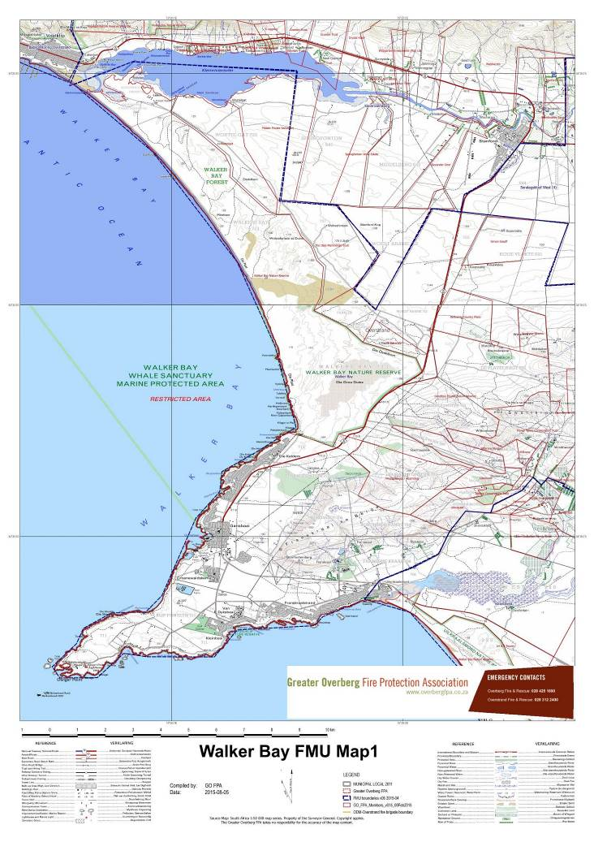
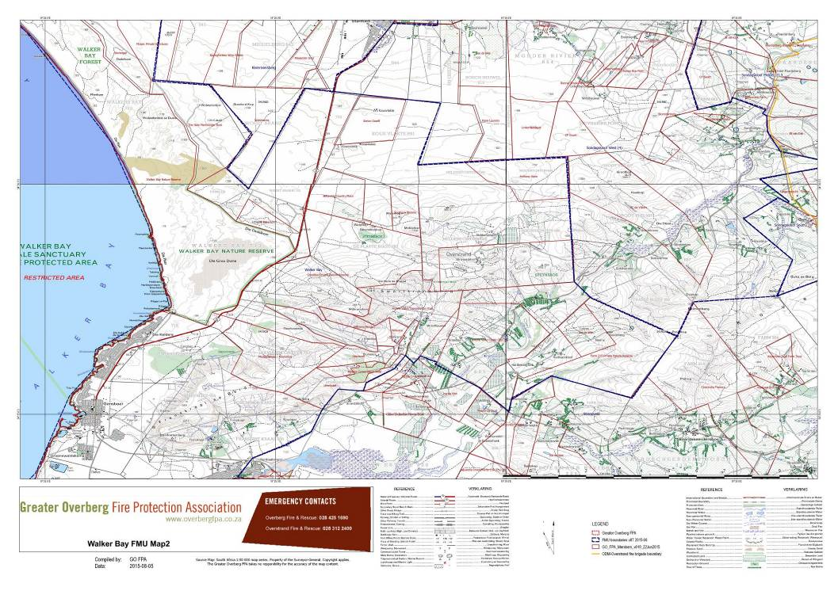
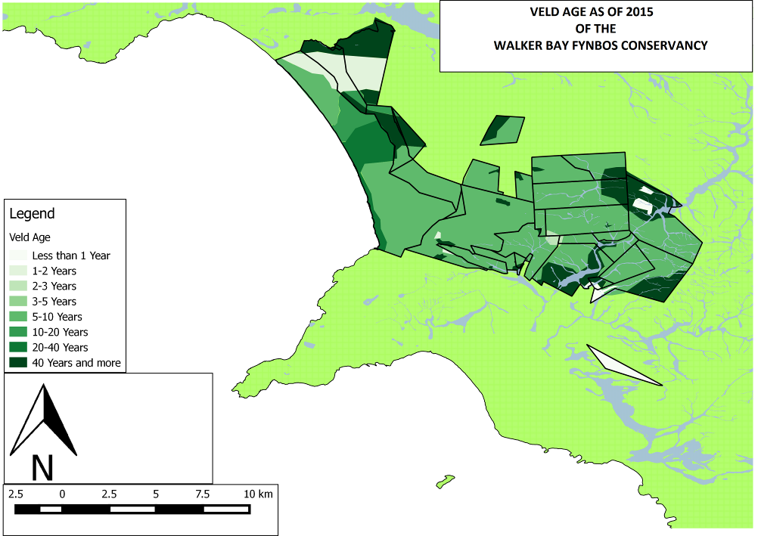
WALKER BAY FYNBOS CONSERVANCY
VELD AGE - 2015
Figure 6 WBFC Veld Age 2015

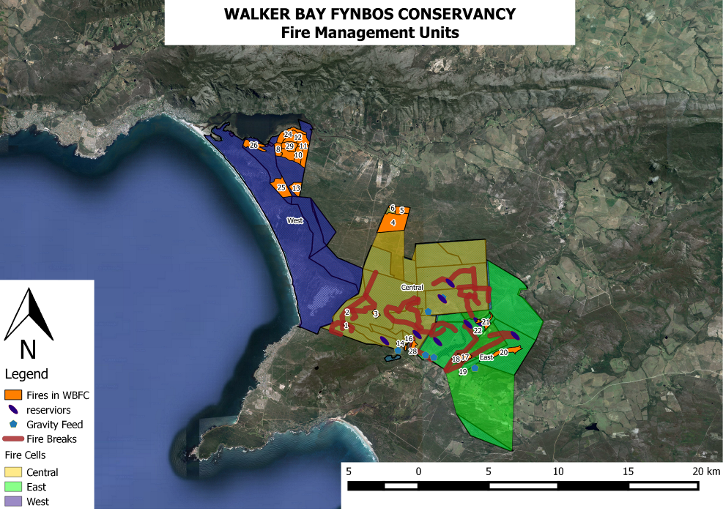
Figure 7 WBFC Fire Management units

2.2.2 INVASIVE ALIEN VEGETATION SPECIES

BACKGROUND

Invasive alien plants remain a threat to the ecosystems within the WBFC. The huge fire in 2006 mobilised government funding to assist with the control of invasive alien vegetation regrowth. The fire removed a large amount of the alien vegetation but also made re-infestation and further invasion a real threat. Through Government assistance 4200 hectares of follow up was completed, providing major impetus in the removal of aliens within the conservancy. The project also employed fifty unemployed people for two years.
Between 2013 and 2015, the Conservancy received R2,7 million from the ABI/DEA alien clearing project, and a total of 6000 hectres was cleared and maintained using these funds, 18 000 person days used employing 90 people between this period from the nearby community of Gansbaai, Stanford and Pearly beach

The Conservancy members are committed to addressing this threat to achieve the following objectives:

OBJECTIVES

- To ensure the alien threat is contained and managed.
- The Conservancy must develop an alien control strategy with priority areas;
- This strategy must prioritise action according to the threat posed to the whole conservancy, this priority is as follows:
- Priority will be afforded to ‘follow-up’ areas to ensure re-infestation does not occur;
- Give preference to young less dense stands before seed banks are built up;
- Follow the gradient from top to bottom i.e. down a slope or a drainage line;
- Leave the densest stands till last;
- Focus on critically endangered, endangered and vulnerable vegetation
- The experience from the industry will be sought to ensure best practise is followed;
- Fire, if appropriately managed and applied may be cost effective for alien clearing;
- Any funds secured from donors or outside sources for the Conservancy must be applied according to these objectives or as agreed to by the Management Committee.

All landowners must collaborate in achieving these objectives as invasive plants will, over time, move across all land within the Conservancy if no or inappropriate action is taken. In this regard the following principles will apply:

- All landowners are responsible for their own alien clearing and land care obligations;
- All landowners must commit to an alien plant control strategy, this must be based on the best practise and the principles set out above;
- An annual alien clearing budget and related annual plan of action has drawn up for the next three years.
- The Conservancy must actively pursue funding opportunities to assist with the clearing of aliens within the Conservancy and even in adjacent areas if it is deemed they may pose a risk to the Conservancy.

BUDGET
The following farms will have been allocated provisional funding to complete alien clearing between 2016 and 2018. Preference will be given to members who are paid up with regard to their membership fees. In 2016, 163 hectares of heavily invested veld will be burnt.

A total of 2460 hectares of new clearing will be done over the next three years, which will bring the total to just under 8 714 hectares of cleared alien vegetation.

We have allocated 16 338 person days for this work to be completed. See the summary below. The detailed plan has been included below.

A detailed description of previous alien infestations and clearing strategy is attached in Appendix 3.

WBFC Detail APO cost summary per site for 2016 till 2018 (initial clearing)
No | Property | 2016 |  |  | 2017 |  |  | 2018
No | Property | Area | Pdays | 295.00 | Area | Pdays | 301.00 | Area | Pdays | 325.00
 | Avuka: Subtotal | 110 | 2107 | R 621 565.00 | 61 | 794 | R 238 994.00
 | R 860 559.00
 | Bhungani: Subtotal | 139 | 1281 | R 377 895.00 |  |  |  | 291 | 1199 | R 389 610.00
 | R 767 505.00
 | Farm215: Subtotal: | 169 | 726 | R 214 170.00 | 8 | 600 | R 180 600.00
 | R 394 770.00
 | Hartebeespoort: Subtotal: | 49 | 336 | R 99 120.00 | 25 | 200 | R 60 200.00
 | R 159 320.00
 | Heidehof: Subtotal: | 195 | 218 | R 64 280.50
 | R 64 280.50
 | Helderfontein: Subtotal: | 302 | 640 | R 188 800.00 |  |  |  | 372 | 1986 | R 645 450.00
 | R 834 250.00
 | Koudevlakte: Subtotal: |  |  |  |  |  |  | 17 | 680 | R 221 000.00
 | R 221 000.00
 | Lomond: Subtotal: | 155 | 294 | R 86 812.60 | 278 | 2748 | R 827 148.00 | 79 | 1264 | R 410 800.00
 | R 1 324 760.60
 | Southern Blooms: Subtotal: | 89 | 445 | R 131 275.00 | 75 | 900 | R 270 900.00
 | R 402 175.00
 | Witkrans Morgan: Subtotal: |  |  |  | 46 | 138 | R 41 538.00
 | R 41 538.00
 |  | 1208 | 5829 | R 1 719 637.60 | 493 | 5380 | R 1 619 380.00 | 759 | 5129 | R 1 666 60.00

We estimate that we will need the following amounts to complete the work:

2016 – R1 719 637.60

2017 – R1 619 380.00

2018 – R1 666 860.00

Total: R 5 005 877.60
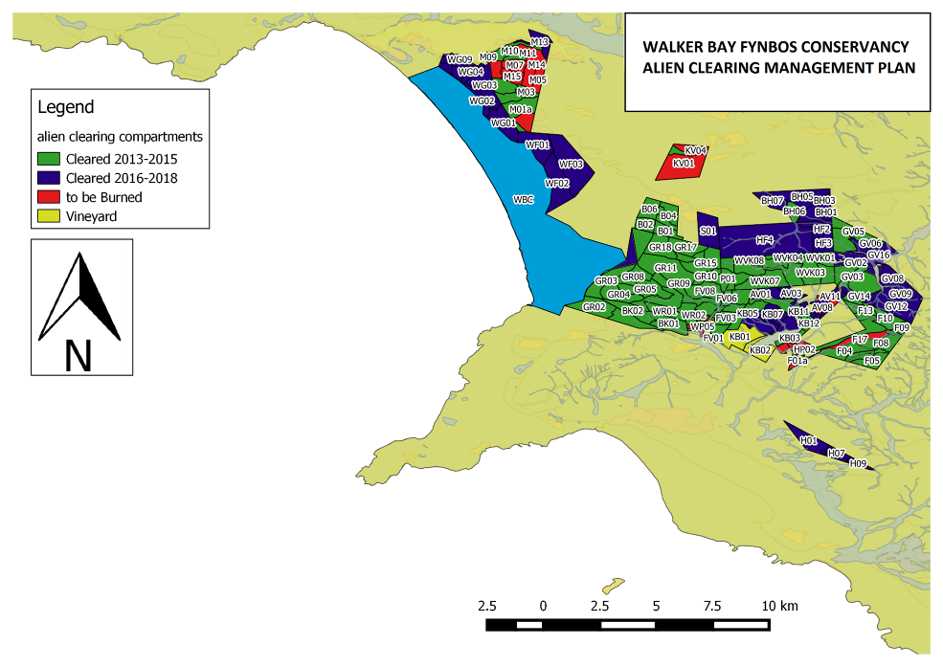
Figure 8 WBFC Alien Clearing Management Plan

2.2.3 FAUNA AND FLORA INVENTORIES

Individual members within the WBFC have undertaken comprehensive surveys of the fauna and flora on their properties. This information has been collated into the species lists shown in the appendices at the bsck of this plan.

Over the next three years, it is planned that under the guidance of the Conservancy Manager more structured and detailed fauna and flora studies will be undertaken across the conservancy.

These surveys will include ongoing camera trap surveys (the data from which will be recorded on GIS) as well as the establishement of the monitoring of permanent vegetation plots within the Conservancy.

3. WALKER BAY FYNBOS CONSERVANCY WITHIN THE GREATER CONSERVATION LANDSCAPE:
The conservancy, together with the Grootbos Foundation and Flower Valley Conservation Trust is embarking on an expansion plan that hopes to link the Walker Bay and Agulhas National Park conservation nodes. This proposed corridor area has been recognised as one of 28 priority climate-adaption landscape corridors in the Western Cape and home to critically endangered fynbos (Pence 2009). The corridor area is home to a significant percentage of the remaining critically endangered Elim ferricrete fynbos, as well as significant areas of critically endangered and highly diverse Overberg sandstone fynbos and vulnerable Agulhas limestone fynbos. These vegetation types are predominantly on private properties and are threatened by the spread of exotic invasive tree species, illegal ploughing for agriculture, over-harvesting of wild flowers and too frequent fires. There is currently no focused conservation effort aimed at protecting this high priority area. Through this project we envisage building relationships with private landowners through a variety of positive interactions and establishing a recognised, functional and viable corridor within five years.
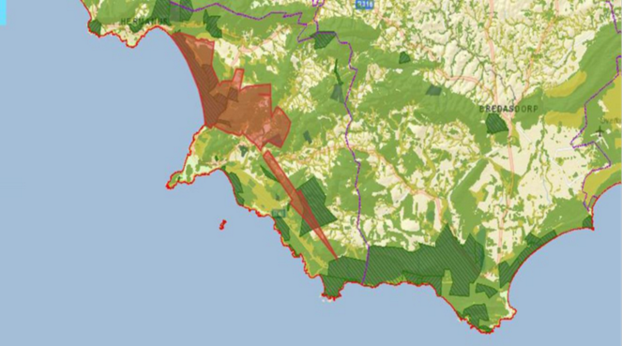
Figure 9 Location map showing existing Walker Bay Fynbos Conservancy in red and Agulhas National Park in green, the proposed corridor area is shown as red arrow linking the two.

REFERENCES

Acocks JPH 1988. Veld types of South Africa. Memoirs of the botanical survey of South Africa No. 57. 146 pp.

Cole NS, Lombard AT, Cowling RM, Euston-Brown DIW, Richardson DM & Heijnis CE 2000. Framework for a conservation plan for the Agulhas Plain, Cape Floristic Region, South Africa. 2nd Edition August 2000. 69 pp.

Cowling RM, Campbell BM, Mustart P, McDonald DJ, Jarman ML, Moll EJ. 1988. Vegetation classification in a floristically complex area: the Agulhas Plain. South African Journal of Botany 54(3):290-300.

Euston-Brown, DIW 2007. Updating and correcting vegetation map and
spatial biodiversity data for the Agulhas Plain. For the Agulhas Biodiversity Initiative (ABI).

Euston-Brown DIW 1999. Agulhas Plain Field Mapping: Final Report. Unpublished report for The Institute for Plant Conservation, University of Cape Town. 13 pp and appendices.

Euston-Brown DIW 2005. A rapid gap analysis of the information available on priority ecosystems in the Agulhas Plain. Unpublished report for the Agulhas Biodiversity Initiative. 19 August 2005. 6pp

Holmes DM & Richardson DM. 1999. Protocols for Restoration based on recruitment dynamics, community structure, and ecosystem function: perspectives from South African Fynbos. Restoration Ecology Vol 7 No. 3: 215-230.

Mucina L & Rutherford MC (eds) 2006. Vegetation of South Africa, Lesotho and Swaziland. SANBI, Pretoria.

Pence G. 2009. Climate Adaptation Scenarios for the Cape Floristic Region. Technical report. Table Mountain Fund.

Raimondo T (199)

APPENDIX 1: WBFC Masters Certificate

APPENDIX 2: WBFC PLANT LIST

Current Valid Name | RSA2012 Red Data List Status | Family
Acrolophia bolusii Rolfe | VU | Orchidaceae
Acrolophia capensis (P.J.Bergius) Fourc. | LC | Orchidaceae
Acrolophia cochlearis (Lindl.) Schltr. & Bolus | LC | Orchidaceae
Acrolophia lamellata (Lindl.) Schltr. & Bolus | LC | Orchidaceae
Acrolophia micrantha (Lindl.) Pfitzer | LC | Orchidaceae
Adenandra uniflora (L.) Willd. | LC | Rutaceae
Adenandra viscida Eckl. & Zeyh. | LC | Rutaceae
Adenocline acuta (Thunb.) Baill. | LC | Euphorbiaceae
Adenocline pauciflora Turcz. | LC | Euphorbiaceae
Adenogramma glomerata (L.f.) Druce | LC | Molluginaceae
Adenogramma lichtensteiniana (Schult.) Druce | LC | Molluginaceae
Adiantum aethiopicum L. | LC | Pteridaceae
Adiantum capillus-veneris L. | LC | Pteridaceae
Afrocanthium mundianum (Cham. & Schltdl.) Lantz | LC | Rubiaceae
Agapanthus africanus (L.) Hoffmanns. subsp. africanus | LC | Agapanthaceae
Agathosma abrupta Pillans | VU | Rutaceae
Agathosma apiculata G.Mey. | LC | Rutaceae
Agathosma cerefolium (Vent.) Bartl. & H.L.Wendl. | LC | Rutaceae
Agathosma ciliaris (L.) Druce | LC | Rutaceae
Agathosma geniculata | Nt | Rutaceae
Agathosma imbricata (L.) Willd. | LC | Rutaceae
Agathosma robusta Eckl. & Zeyh. | VU | Rutaceae
Agathosma serpyllacea Licht. ex Roem. & Schult. | LC | Rutaceae
Aizoon sarmentosum L.f. | LC | Aizoaceae
Albuca acuminata Baker | LC | Hyacinthaceae
Albuca canadensis | LC | Hyacinthaceae
Albuca cooperi Baker | LC | Hyacinthaceae
Albuca crinifolia Baker | DDT | Hyacinthaceae
Albuca flaccida Jacq. | LC | Hyacinthaceae
Albuca fragrans Jacq. | LC | Hyacinthaceae
Albuca juncifolia Baker subsp. juncifolia | NE | Hyacinthaceae
Alectra lurida Harv. | LC | Orobanchaceae
Alectra sessiliflora (Vahl) Kuntze var. sessiliflora | NE | Orobanchaceae
Aloe brevifolia | VU | Asphodelaceae
Aloe juddii Van Jaarsv. | NE | Asphodelaceae
Amaryllis belladonna L. | LC | Amarymllidaceae
Amphithalea biovulata (Bolus) Granby | LC | Fabaceae
Amphithalea ericifolia (L.) Eckl. & Zeyh. subsp. ericifolia | LC | Fabaceae
Anaxeton asperum (Thunb.) DC | LC | Asteraceae
Anemone vesicatoria (L.f.) Prantl subsp. Grossa (H.Rasm.) J.C.Manning & Goldblatt | LC | Ranunculaceae
Anemone vesicatoria (L.f.) Prantl subsp. Humilis (H.Rasm.) J.C.Manning & Goldblatt | LC | Ranunculaceae
Anginon difforme (L.) B.L.Burtt | LC | Apiaceae
Anisodontea scabrosa (L.) Bates | LC | Malvaceae
Annesorhiza macrocarpa Eckl. & Zeyh. | LC | Apiaceae
Anthospermum aethiopicum L. | LC | Rubiaceae
Anthospermum hirtum Cruse | LC | Rubiaceae
Anthospermum prostratum Sond. | LC | Rubiaceae
Anthospermum spathulatum Spreng. subsp. spathulatum | LC | Rubiaceae
Apodytes dimidiata E.Mey. ex Arn. subsp. dimidiata | LC | Icacinaceae
Aponongeton distachyos L.F | LC | Aponogetonaceae
Arctopus echinatus L. | LC | Apiaceae
Arctotheca calendula (L.) Levyns | LC | Asteraceae
Arctotheca prostrata (Salisb.) Britten | LC | Asteraceae
Arctotis acaulis L. | LC | Asteraceae
Arctotis adpressa DC. | LC | Asteraceae
Arctotis schlechteri K.Lewin | LC | Asteraceae
Aristea africana (L.) Hoffmanns. | LC | Iridaceae
Aristea bakeri Klatt | LC | Iridaceae
Aristea capitata (L.) Ker Gawl | LC | Iridaceae
Aristea glauca Klatt | LC | Iridaceae
Aristea oligocephala Baker | LC | Iridaceae
Aristea spiralis (L.f.) Ker Gawl. | LC | Iridaceae
Aristea teretifolia | EN | Iridaceae
Artemisia afra Jacq. ex Willd. var. afra | LC | Asteraceae
Aspalathus batodes Eckl. & Zeyh subsp. Spinulifolia R.Dahlgren | NT | Fabaceae
Aspalathus biflora E.Mey. subsp. biflora | LC | Fabaceae
Aspalathus biflora E.Mey. subsp. longicarpa R.Dahlgren | LC | Fabaceae
Aspalathus caledonensis R.Dahlgren | LC | Fabaceae
Aspalathus callosa L. | LC | Fabaceae
Aspalathus candicans Aiton f. | EN | Fabaceae
Aspalathus ciliaris L. | LC | Fabaceae
Aspalathus crassisepala R.Dahlgren | LC | Fabaceae
Aspalathus forbesii Harv. | LC | Fabaceae
Aspalathus globulosa E.Mey. | VU | Fabaceae
Aspalathus hirta E.Mey. subsp. hirta | LC | Fabaceae
Aspalathus hispida Thunb. subsp. hispida | LC | Fabaceae
Aspalathus incurvifolia Vogel ex Walp. | LC | Fabaceae
Aspalathus linguiloba R.Dahlgren | LC | Fabaceae
Aspalathus microphylla DC. | LC | Fabaceae
Aspalathus nigra L. | LC | Fabaceae
Aspalathus pycnantha R.Dahlgren | VU | Fabaceae
Aspalathus salteri L.Bolus | NT | Fabaceae
Aspalathus sericea P.J.Bergius | LC | Fabaceae
Asparagus aethiopicus L. | LC | Asparagaceae
Asparagus asparagoides (L.) Druce | LC | Asparagaceae
Asparagus capensis L. var capensis | LC | Asparagaceae
Asparagus lignosus Burm.f. | LC | Asparagaceae
Asparagus ovatus T.M.Salter | LC | Asparagaceae
Asparagus rubicundus P.J.Bergius | LC | Asparagaceae
Asparagus scandens Thunb. | LC | Asparagaceae
Asparagus stipulaceus Lam. | NT | Asparagaceae
Asparagus volubilis Thunb. | LC | Asparagaceae
Asplenium adiantum-nigrum L. var. adiantum-nigrum | LC | Aspleniaceae
Astephanus triflorus (L.f.) Schult. | LC | Apocynaceae
Athanasia dentata (L.) L. | LC | Asteraceae
Athanasia quinquedentata Thunb. subsp. quinquedentata | LC | Asteraceae
Athanasia trifurcata (L.) L. | LC | Asteraceae
Aulax umbellata (Thunb.) R.Br. | NT | Proteaceae
Babiana ambigua (Roem. & Schult.) G.J.Lewis | LC | Iridaceae
Babiana nana (Andrews) Spreng. Subsp. nana | EN | Iridaceae
Babiana tubulosa (Burm.f.) Ker Gawl. | VU | Iridaceae
Baeometra uniflora (Jacq.) G.J.Lewis | LC | Colchicaceae
Bartholina etheliae Bolus | LC | Orchidaceae
Berkheya barbata (L.f.) Hutch | LC | Asteraceae
Berkheya rigida (Thunb.) Erwart, Jean White & B.Rees | LC | Asteraceae
Berula erecta (Huds.) Coville subsp. thunbergii (DC.) B.L.Burtt | LC | Apiaceae
Berzelia abrotanoides (L.) Brongn | LC | Bruniaceae
Berzelia lanuginosa (L.) Brongn. | LC | Bruniaceae
Blechnum attenuatum (Sw.) Mett | LC | Blechnaceae
Bobartia indica L. | LC | Iridaceae
Bobartia longycima J.B. Gillet subsp. Longicyma | NT | Iridaceae
Bolusafra bituminosa (L.) Kuntze | LC | Fabaceae
Bonatea speciosa (L.f.) Willd. | LC | Orchidaceae
Brachypodium flexum Nees | LC | Poaceae
Brunia laevis Thunb. | LC | Bruniaceae
Brunia nodiflora | LC | Bruniaceae
Brunia paleacea P.J.Bergius | LC | Bruniaceae
Brunsvigia orientalis (L.) Aiton ex Eckl. | LC | Amarymllidaceae
Bulbine alooides (L.) Willd | LC | Asphodelaceae
Bulbine annua (L.) Willd. | LC | Asphodelaceae
Bulbine favosa (Thunb.) Schult. & Schult.f | LC | Asphodelaceae
Bulbine foleyi E.Phillips | LC | Asphodelaceae
Bulbine lagopus (Thunb.) N.E.Br. | LC | Asphodelaceae
Bulbinella triquetra (L.f.) Kunth | LC | Asphodelaceae
Caesia contorta (L.f.) T.Durand & Schinz | LC | Hemerocallidaceae
Cannomois virgata (Rottb.) Steud. | LC | Restionaceae
Canthium inerme (L.f.) Kuntze | LC | Rubiaceae
Capnophyllum lutzeyeri Magee & B.-E. van Wyk | VU | Apiaceae
Carissa bispinosa (L.) Desf. Ex Brenan | LC | Apocynaceae
Carpacoce vaginellata T.M.Salter | LC | Rubiaceae
Carpanthea pomeridiana (L.) N.E.Br. | LC | Aizoaceae
Carpobrotus acinaciformis (L.) L.Bolus | LC | Aizoaceae
Carpobrotus edulis (L.) L.Bolus subsp. edulis | LC | Aizoaceae
Caryotophora skiatophytoides Leistner | EN | Aizoaceae
Cassine peragua L. subsp. peragua | LC | Celastraceae
Cassine schinoides (Spreng.) R.H. Archer | LC | Celastraceae
Cassytha ciliolata Nees | LC | Lauraceae
Celtis africana Burm.f. | LC | Celtidaceae
Centella affinis (Eckl. & Zeyh.) Adamson var. affinis | LC | Apiaceae
Centella asiatica (L.) Urb. | LC | Apiaceae
Centella macrocarpa (Rich.) Adamson var. macrocarpa | LC | Apiaceae
Centella tridentata (L.f.) Drude ex Domin var. tridentata | LC | Apiaceae
Cerastium capense Sond. | LC | Caryophyllaceae
Ceratandra atrata (L.) T.Durand & Schinz | LC | Orchidaceae
Chaenostoma caerulea | LC | Scrophulariaceae
Chaenostoma hispidum (Thunb.) Benth. | LC | Scrophulariaceae
Chamarea capensis (Thunb.) Eckl. & Zeyh. | LC | Apiaceae
Chascanum cernuum (L.) E.Mey. | LC | Verbenaceae
Chasmanthe aethiopica (L.) N.E.Br. | LC | Iridaceae
Chionanthus foveolatus (E.Mey.) Stearn subsp. foveolatus | LC | Oleaceae
Chironia baccifera L. | LC | Gentianaceae
Chironia decumbens Levyns | LC | Gentianaceae
Chironia jasminoides | LC | Gentianaceae
Chironia linoides L. subsp. linoides | LC | Gentianaceae
Chironia stokoei I.Verd. | RARE | Gentianaceae
Chironia tetragona L.f. | LC | Gentianaceae
Chrysanthemoides monilifera (L.) Norl. subsp. monilifera | NE | Asteraceae
Chrysocoma coma-aurea L. | LC | Asteraceae
Cineraria geifolia (L.) L. | LC | Asteraceae
Cissampelos capensis L.f. | LC | Menispermaceae
Cleretum bellidiforme (Burm.f.) G.D.Rowley | LC | Aizoaceae
Cliffortia anthospermoides Fellingham | EN | Rosaceae
Cliffortia atrata Weim | LC | Rosaceae
Cliffortia ceresana C.M.Whitehouse | RARE | Rosaceae
Cliffortia drepanoides Eckl. & Zeyh. | LC | Rosaceae
Cliffortia falcata L.f. | LC | Rosaceae
Cliffortia ferruginea L.f. | LC | Rosaceae
Cliffortia filifolia L.f. | LC | Rosaceae
Cliffortia ilicifolia L. var. ilicifolia | LC | Rosaceae
Cliffortia obcordata L.f. | LC | Rosaceae
Cliffortia phyllanthoides Schltr. | LC | Rosaceae
Cliffortia stricta Weim | LC | Rosaceae
Cliffortia strobilifera L. | LC | Rosaceae
Clutia alaternoides L. var. alaternoides | LC | Euphorbiaceae
Clutia ericoides Thunb. var. ericoides | LC | Euphorbiaceae
Clutia polygonoides L. | LC | Euphorbiaceae
Colchicum capense (L.) J.C.Manning & Vinn. subsp. capense | LC | Colchicaceae
Colchicum eucomoides (Jacq.) J.C.Manning & Vinn. | LC | Colchicaceae
Coleonema album (Thunb.) Bartl. & H.L.Wendl. | LC | Rutaceae
Colpoon compressa (P.J.Bergius) A.DC. | LC | Santalaceae
Colpoon speciosa (A.W.Hill) P.A.Bean | VU | Santalaceae
Conium chaerophylloides (Thunb.) Sond. | LC | Apiaceae
Convolvulus capensis Burm.f. | LC | Convolvulaceae
Corycium bicolorum (Thunb.) Sw. | NE | Orchidaceae
Corycium excisum Lindl. | NE | Orchidaceae
Corycium orobanchoides (L.f.) Sw. | NE | Orchidaceae
Corymbium africanum L. subsp. africanum | LC | Asteraceae
Corymbium glabrum L. var. glabrum | LC | Asteraceae
Corymbium villosum L.f. | LC | Asteraceae
Cotula turbinata L. | LC | Asteraceae
Cotyledon orbiculata L. var. orbiculata (Haw.) DC | LC | Crassulaceae
Cotyledon velutina Hook.f. | LC | Crassulaceae
Crassula biplanata Haw | LC | Crassulaceae
Crassula campestris (Eckl. & Zeyh.) Endl. ex Walp. | LC | Crassulaceae
Crassula capensis (L.) Baill. var. capensis | LC | Crassulaceae
Crassula depressa (Eckl. & Zeyh.) Toelken | DDT | Crassulaceae
Crassula dichotoma L. | LC | Crassulaceae
Crassula expansa Dryand. subsp. expansa | LC | Crassulaceae
Crassula expansa Dryand. subsp. filicaulis (Haw.) Toelken | LC | Crassulaceae
Crassula fascicularis Lam. | LC | Crassulaceae
Crassula glomerata P.J.Bergius | LC | Crassulaceae
Crassula natans Thunb. var. natans | LC | Crassulaceae
Crassula nudicaulis L. Var. nudicaulis | LC | Crassulaceae
Crassula pellucida L. subsp. pellucida | LC | Crassulaceae
Crassula subulata L. var. subulata | LC | Crassulaceae
Cullumia setosa (L.) R.Br. var. setosa | LC | Asteraceae
Cullumia squarrosa (L.) R.Br. | VU | Asteraceae
Cunonia capensis L. | LC | Cunoniaceae
Curtisia dentata (Burm.f.) C.A.Sm. | NT | Cornaceae
Cyanella hyacinthoides L. | LC | Tecophilaeaceae
Cyanella lutea L.f. subsp. Lutea | LC | Tecophilaeaceae
Cyclopia genistoides (L.) R.Br. | NT | Fabaceae
Cymbopogon marginatus (Steud.) Stapf ex Burtt Davy | LC | Poaceae
Cynanchum africanum (L.) Hoffmanns. | LC | Apocynaceae
Cynanchum obtusifolium L.f. | LC | Apocynaceae
Cynodon dactylon (L.) Pers | LC | Poaceae
Cyperus congestus Vahl | LC | Cyperaceae
Cyperus thunbergii Vahl | LC | Cyperaceae
Cyphia volubilis (Burm.f.) Willd. var. volubilis | LC | Lobeliaceae
Cyrtanthus angustifolia | LC | Amarymllidaceae
Cyrtanthus carneus Lindl. | VU | Amarymllidaceae
Cyrtanthus leucanthus Schltr. | EN | Amarymllidaceae
Cyrtanthus ventricosus Wiild | LC | Amarymllidaceae
Cysticapnos vesicaria (L.) Fedde subsp. Vesicaria | LC | Fumariaceae
Dasispermum grandicarpum Magee & B.-E. van Wyk | DDT | Apiaceae
Dasispermum hispida (Thunb.) Magee & B.-E. van Wyk | LC | Apiaceae
Dasispermum tenuis (Sond.) Magee & B.-E. van Wyk | LC | Apiaceae
Datura stramonium L. | NE | Solanaceae
Delosperma guthriei Lavis | VU | Aizoaceae
Delosperma litorale (Kensit) L.Bolus | LC | Aizoaceae
Dianthus albens Aiton | LC | Caryophyllaceae
Dianthus caespitosus Thunb. subsp. caespitosus | LC | Caryophyllaceae
Diascia capensis (L.) Britten | LC | Scrophulariaceae
Didymodoxa capensis (L.f.) Friis & Wilmot-Dear var. capensis | LC | Urticaceae
Dilatris pillansii W.F.Barker | LC | Haemodoraceae
Dimorphotheca nudicaulis (L.) DC. var. nudicaulis | LC | Asteraceae
Dimorphotheca pluvialus | LC | Asteraceae
Diosma awilana I.Williams | EN | Rutaceae
Diosma hirsuta L. | LC | Rutaceae
Diosma oppositifolia | LC | Rutaceae
Diosma subulata J.C.Wendl. | VU | Rutaceae
Diospyros whyteana (Hiern) F.White | LC | Ebenaceae
Dipogon lignosus (L.) Verdc. | LC | Fabaceae
Disa bivalvata (L.f.) T.Durand & Schinz | LC | Orchidaceae
Disa bracteata Sw. | LC | Orchidaceae
Disa cernua (Thunb.) Sw. | VU | Orchidaceae
Disa comosa (Rchb.f.) Schltr. | LC | Orchidaceae
Disa cornuta (L.) Sw. | LC | Orchidaceae
Disa densiflora (Lindl.) Bolus | LC | Orchidaceae
Disa filicornis (L.f.) Thunb | LC | Orchidaceae
Disa graminifolia Ker Gawl. ex Spreng. | LC | Orchidaceae
Disa hallackii Rolfe | EN | Orchidaceae
Disa purpurascens Bolus | NT | Orchidaceae
Disa racemosa L.f. | LC | Orchidaceae
Disa reticulata Bolus | LC | Orchidaceae
Disa schizodioides Sond. | RARE | Orchidaceae
Disa tenuifolia Sw. | LC | Orchidaceae
Disa tripetaloides (L.f.) N.E.Br. | LC | Orchidaceae
Dischisma ciliatum (P.J.Bergius) Choisy subsp. ciliatum | LC | Scrophulariaceae
Disparago anomala Schltr. ex Levyns | LC | Asteraceae
Disparago ericoides (P.J.Bergius) Gaertn. | LC | Asteraceae
Disperis capensis (L.f.) Sw var. brevicaudata Rolfe | LC | Orchidaceae
Disperis capensis (L.f.) Sw. var. capensis | LC | Orchidaceae
Disperis paludosa Harv. Ex Lindl. | LC | Orchidaceae
Disperis villosa (L.f.) Sw. | LC | Orchidaceae
Drimia exuviata (Jacq.) Jessop | LC | Hyacinthaceae
Drimia filifolia (Jacq.) J.C.Manning & Goldblatt | LC | Hyacinthaceae
Drimia media Jacq. | LC | Hyacinthaceae
Droguetia iners (Forssk.) Schweinf. subsp. iners | LC | Urticaceae
Drosanthemum austricola L.Bolus | VU | Aizoaceae
Drosanthemum intermedium (L.Bolus) L.Bolus | LC | Aizoaceae
Drosera aliciae Raym.-Hamet | LC | Droseraceae
Drosera capensis L. | LC | Droseraceae
Drosera cistiflora L. | LC | Droseraceae
Drosera glabripes (Harv.) Stein | LC | Droseraceae
Drosera trinervia Spreng. | LC | Droseraceae
Edmondia sesamoides (L.) Hilliard | LC | Asteraceae
Ehrharta calycina Sm. | LC | Poaceae
Ehrharta erecta Lam. var. erecta | LC | Poaceae
Ehrharta rehmannii Stapf subsp. subspicata (Stapf) Gibbs Russ. | LC | Poaceae
Ehrharta villosa J.H.Schult. var. villosa | LC | Poaceae
Elegia ebracteata (Kunth) Moline & H.P.Linder | NE | Restionaceae
Elegia filacea Mast. | LC | Restionaceae
Elegia juncea L. | LC | Restionaceae
Elegia microcarpa (Kunth) Moline & H.P.Linder | NE | Restionaceae
Elegia muirii Pillans | LC | Restionaceae
Elegia tectorum (L.f.) Moline & H.P.Linder | NE | Restionaceae
Elegia thyrsifera (Rottb.) Pers. | LC | Restionaceae
Empodium gloriosum (Nel) B.L.Burtt | LC | Hypoxidaceae
Empodium plicatum (Thunb.) Garside | LC | Hypoxidaceae
Epilobium hirsutum L. | LC | Onagraceae
Epischoenus adnatus Levyns | LC | Cyperaceae
Eragrostis curvula (Schrad.) Nees | LC | Poaceae
Erepsia anceps (Haw.) Schwantes | LC | Aizoaceae
Erepsia simulans (L.Bolus) Klak | VU | Aizoaceae
Erica ampullacea Curtis var. ampullacea | LC | Ericaceae
Erica articularis L. var. articularis | LC | Ericaceae
Erica axillaris Thunb. | LC | Ericaceae
Erica axilliflora Bartl. | LC | Ericaceae
Erica canescens J.C.Wendl. var. canescens | LC | Ericaceae
Erica cerinthoides L. var. cerinthoides | LC | Ericaceae
Erica coccinea L. subsp. coccinea | LC | Ericaceae
Erica colorans Andrew | VU | Ericaceae
Erica corifolia L. var. corifolia | LC | Ericaceae
Erica curvifolia | LC | Ericaceae
Erica discolor Andrews | LC | Ericaceae
Erica ericoides (L.) E.G.H.Oliv | LC | Ericaceae
Erica fascicularis L.f. var. fascicularis | LC | Ericaceae
Erica glabella Thunb. subsp. glabella | LC | Ericaceae
Erica globiceps (N.E.Br.) E.G.H.Oliv. Subsp. Globiceps | LC | Ericaceae
Erica hispidula L. var. hispidula | LC | Ericaceae
Erica hispidula L. var. micrantha Benth. | DDT | Ericaceae
Erica hispidula L. var. serpyllifolia (Andrews) Benth. | DDT | Ericaceae
Erica hispidula L. var. viscidula (L.Bolus) Dulfer | DDT | Ericaceae
Erica holosericea Salisb. var. parviflora Bolus | DDT | Ericaceae
Erica irbyana Andrews | LC | Ericaceae
Erica irregularis Benth. | EN | Ericaceae
Erica longiaristata Benth | LC | Ericaceae
Erica magnisylvae E.G.H.Oliv. | VU | Ericaceae
Erica mammosa L. | LC | Ericaceae
Erica nudiflora L. | LC | Ericaceae
Erica parviflora L. var. parviflora | LC | Ericaceae
Erica penicilliformis Salisb. var. penicilliformis | LC | Ericaceae
Erica plukenetii L. subsp. lineata (Benth.) E.G.H.Oliv. & I.M.Oliv | LC | Ericaceae
Erica propinqua Guthrie & Bolus | LC | Ericaceae
Erica puberuliflora E.G.H.Oliv. | LC | Ericaceae
Erica pulchella Houtt. var. pulchella | LC | Ericaceae
Erica riparia H.A.Baker | EN | Ericaceae
Erica sessiliflora L.f. | LC | Ericaceae
Erica sitiens Klotzsch | LC | Ericaceae
Erica subdivaricata P.J.Bergius | LC | Ericaceae
Erica vestita Thunb. | LC | Ericaceae
Erica viscaria L. subsp. Macrosepala E.G.H.Oliv. & I.M.Oliv | LC | Ericaceae
Eriocephalus africanus L. var. paniculatus (Cass.) M.A.N.Müll.,P.P.J.Herman & Kolberg | LC | Asteraceae
Eriocephalus racemosus L. var. racemosus | LC | Asteraceae
Erodium botrys (Cav.) Bertol | NE | Geraniaceae
Euclea racemosa Murray subsp. racemosa | LC | Ebenaceae
Eulophia aculeata (L.f.) Spreng. subsp. aculeata | LC | Orchidaceae
Eulophia litoralis Schltr. | EN | Orchidaceae
Euphorbia ecklonii (Klotzch & Garcke) Baill | LC | Euphorbiaceae
Euphorbia erythrina Link var. erythrina | NE | Euphorbiaceae
Euphorbia silenifolia (Haw.) Sweet | LC | Euphorbiaceae
Euphorbia tuberosa L. | LC | Euphorbiaceae
Euryops abrotanifolius (L.) DC. | LC | Asteraceae
Evotella carnosum (Lindl.) J.C.Manning & Goldblatt | LC | Orchidaceae
Exomis microphylla (Thunb.) Aellen var. axyrioides (Fenzl)Aellen | LC | Chenopodiaceae
Felicia aethiopica (Burm.f.) Bolus & Wolley-Dod ex Adamson & T.M.Salter subsp. aethiopica | LC | Asteraceae
Felicia amoena (Sch.Bip.) Levyns subsp. latifolia Grau | LC | Asteraceae
Felicia tenella (L.) Nees subsp. longifolia (DC.) Grau | LC | Asteraceae
Ferraria crispa Burm. | LC | Iridaceae
Festuca scabra Vahl | LC | Poaceae
Ficinia bulbosa (L.) Nees | LC | Cyperaceae
Ficinia deusta (P.J.Bergius) Levyns | LC | Cyperaceae
Ficinia filiformis (Lam.) Schrad | LC | Cyperaceae
Ficinia gracilis Schrad. | LC | Cyperaceae
Ficinia indica (Lam.) Pfeiff. | LC | Cyperaceae
Ficinia nodosa (Rottb.) Goetgh., Muasya & D.A. Simpson | LC | Cyperaceae
Ficinia paradoxa (Schrad.) Nees | LC | Cyperaceae
Ficinia secunda (Vahl) Kunth | LC | Cyperaceae
Ficinia trichodes (Schrad.) Benth. & Hook.f. | LC | Cyperaceae
Ficinia tristachya (Rottb.) Nees | LC | Cyperaceae
Fumaria muralis Sond. Ex W.D.J.Koch subsp. Muralis | NE | Fumariaceae
Galenia ecklonis Walp. | LC | Aizoaceae
Galium tomentosum Thunb. | LC | Rubiaceae
Gazania pectinata (Thunb.) Spreng. | LC | Asteraceae
Geissorhiza aspera Goldblatt | LC | Iridaceae
Geissorhiza ovata (Burm.f.) Asch. & Graebn | LC | Iridaceae
Geranium incanum Burm.f. var. incanum | LC | Geraniaceae
Geranium ornithopodon Eckl. & Zeyh. | LC | Geraniaceae
Gerbera crocea (L.) Kuntze | LC | Asteraceae
Gerbera linnaei Cass | LC | Asteraceae
Gerbera piloselloides (L.) Cass. | LC | Asteraceae
Gerbera tomentosa DC. | LC | Asteraceae
Gladiolus brevifolius Jacq. | LC | Iridaceae
Gladiolus bullatus Thunb. Ex G.J.Lewis | LC | Iridaceae
Gladiolus carinatus Aiton | LC | Iridaceae
Gladiolus carneus D.Delaroche | LC | Iridaceae
Gladiolus cunonius (L.) Gaertn. | LC | Iridaceae
Gladiolus debilis Sims | LC | Iridaceae
Gladiolus gracilis Jacq. | LC | Iridaceae
Gladiolus hirsutus Jacq. | LC | Iridaceae
Gladiolus liliaceus Houtt | LC | Iridaceae
Gladiolus maculatus Sweet | LC | Iridaceae
Gladiolus martleyi L.Bolus | LC | Iridaceae
Gladiolus meridionalis G.J.Lewis | LC | Iridaceae
Gladiolus miniatus Eckl. | VU | Iridaceae
Gladiolus overbergensis Goldblatt & M.P.de Vos | VU | Iridaceae
Gladiolus recurvus L. | VU | Iridaceae
Gladiolus rogersii Baker | LC | Iridaceae
Gladiolus rudis Litcht. Ex. Roem. & Schult | LC | Iridaceae
Gladiolus trichonemifolius Ker. Gawl | VU | Iridaceae
Gladiolus vaginatus F.Bolus | VU | Iridaceae
Gladiolus variegatus (G.J.Lewis) Goldblatt & J.C.Manning | VU | Iridaceae
Gnidia galpinii C.H. Wright | LC | Thymelaeaceae
Gnidia galpinii C.H.Wright | LC | Thymelaeaceae
Gnidia juniperifolia Lam. | LC | Thymelaeaceae
Gnidia oppositifolia | LC | Thymelaeaceae
Gnidia pinifolia L. | LC | Thymelaeaceae
Gnidia squarrosa (L.) Druce | LC | Thymelaeaceae
Gnidia subulata Lam. | LC | Thymelaeaceae
Gnidia tenella Meisn. | LC | Thymelaeaceae
Gomphocarpus fruticosus (L.) Aiton f. subsp. fruticosus | LC | Apocynaceae
Grewia occidentalis L. Var. occidentalis | LC | Malvaceae
Grubbia rosmairinifolia P.J. Bergius subsp. Rosmairinifolia var. rosmarinifolia | LC | Grubbiaceae
Gymnodiscus capillaris (L.f.) DC. | LC | Asteraceae
Gymnosporia buxifolia (L.) Szyszyl. | LC | Celastraceae
Haemanthus coccineus L. | LC | Amarymllidaceae
Haemanthus sanguineus Jacq. | LC | Amarymllidaceae
Halleria lucida L. | LC | Scrophulariaceae
Haplocarpha lanata (Thunb.) Less. | LC | Asteraceae
Harveya capensis Hook. | LC | Orobanchaceae
Harveya pauciflora (Benth.) Hiern | LC | Orobanchaceae
Harveya squamosa (Thunb.) Steud. | LC | Orobanchaceae
Hebenstretia dentata L. | LC | Scrophulariaceae
Hebenstretia repens Jaroscz | LC | Scrophulariaceae
Hebenstretia robusta E.Mey. | LC | Scrophulariaceae
Helichrysum cochleariforme DC. | NT | Asteraceae
Helichrysum crispum (L.) D.Don | LC | Asteraceae
Helichrysum cymosum (L.) D.Don subsp. Calvum Hilliard | LC | Asteraceae
Helichrysum cymosum (L.) D.Don subsp. cymosum | LC | Asteraceae
Helichrysum dasyanthum (Willd.) Sweet | LC | Asteraceae
Helichrysum foetidum (L.) Moench var. foetidum | NE | Asteraceae
Helichrysum indicum (L.) Grierson | LC | Asteraceae

Helichrysum niveum (L.) Less. | LC | Asteraceae
Helichrysum pandurifolium Schrank | LC | Asteraceae
Helichrysum patulum (L.) D.Don | LC | Asteraceae
Helichrysum retortum (L.) Willd. | LC | Asteraceae
Helichrysum spiralepis Hilliard & B.L.Burtt | LC | Asteraceae
Helichrysum tenuiculum DC. | LC | Asteraceae
Helichrysum teretifolium (L.) D.Don | LC | Asteraceae
Helictotrichon capense Schweick. | LC | Poaceae
Heliophila acuminata (Eckl. & Zeyh.) Steud. | LC | Brassicaceae
Heliophila africana (L.) Marais | LC | Brassicaceae
Heliophila bulbostyla P.E.Barnes | LC | Brassicaceae
Heliophila juncea (P.J.Bergius) Druce | LC | Brassicaceae
Heliophila linearis (Thunb.) DC. var. linearifolia (Burch. ex DC.) Marais | LC | Brassicaceae
Heliophila linearis (Thunb.) DC. var. reticulata (Eckl. & Zeyh.) Marais | VU | Brassicaceae
Heliophila pusilla L.f. var. pusilla | LC | Brassicaceae
Heliophila subulata var. glabrata. Ex DC | LC | Brassicaceae
Hellmuthia membranacea (Thunb.) R.W.Haines & Lye | LC | Cyperaceae
Hemimeris racemosa (Houtt.) Merr. | LC | Scrophulariaceae
Hemimeris sabulosa L.f. | LC | Scrophulariaceae
Hermannia flammea Jacq. | LC | Malvaceae
Hermannia grossularifolia L. | LC | Malvaceae
Hermannia hyssopifolia L. | LC | Malvaceae
Hermannia joubertiana Harv. | LC | Malvaceae
Hermannia rudis N.E.Br | LC | Malvaceae
Hermannia scabricaulis T.M.Salter | LC | Malvaceae
Hermannia ternifolia C.Presl ex Harv. | LC | Malvaceae
Hermannia trifoliata L. | LC | Malvaceae
Hermas villosa (L.) Thunb. | LC | Apiaceae
Herniaria capensis Bartl. | LC | Caryophyllaceae
Hesperantha falcata (L.f.) Ker Gawl. | LC | Iridaceae
Hesperantha radiata (Jacq.) Ker Gawl. Subsp. Radiata | LC | Iridaceae
Hibiscus aethiopicus L. var. aethiopicus | LC | Malvaceae
Hippia frutescens (L.) L. | LC | Asteraceae
Hippia hutchinsonii Merxm. | RARE | Asteraceae
Holothrix cernua (Burm.f.) Schelpe | LC | Orchidaceae
Holothrix exilis Lindl. | LC | Orchidaceae
Holothrix grandiflora (Sond.) Rchb.f. | DDD | Orchidaceae
Holothrix mundii Sond. | LC | Orchidaceae
Holothrix schlechteriana Schltr. ex Kraenzl. | LC | Orchidaceae
Holothrix villosa Lindl. var. villosa | LC | Orchidaceae
Hyobanche sanguinea L. | LC | Orobanchaceae
Hypodiscus aristatus (Thunb.) C. Krauss | LC | Restionaceae
Hypodiscus willdenowia (Nees) Mast. | LC | Restionaceae
Ifloga repens (L.) Hilliard & B.L.Burtt | LC | Asteraceae
Ilex mitis (L.) Radlk. Var. mitis | DECLINING | Aquifoliaceae
Indigofera angustifolia L. var. angustifolia | LC | Fabaceae
Indigofera brachystachya (DC.) E.Mey. | LC | Fabaceae
Indigofera capillaris Thunb. | LC | Fabaceae
Indigofera incana Thunb. | LC | Fabaceae
Indigofera nigromontana Eckl. & Zeyh. | LC | Fabaceae
Indigofera porrecta Eckl. & Zeyh. var. porrecta | NE | Fabaceae
Isolepis antarctica (L.) Roem. & Schult. | LC | Cyperaceae
Isolepis incomtula Nees | LC | Cyperaceae
Isolepis marginata (Thunb.) A.Dietr. | LC | Cyperaceae
Itasina filifolia (Thunb.) Raf. | LC | Apiaceae
Ixia dubia Vent. | DECLINING | Iridaceae
Ixia flexuosa L. | LC | Iridaceae
Ixia odorata Ker Gawl. | LC | Iridaceae
Ixia orientalis L.Bolus | LC | Iridaceae
Ixia polystachya L. var. polystachya | LC | Iridaceae
Jamesbrittenia albomarginata Hilliard | LC | Scrophulariaceae
Jordaaniella dubia (Haw.) H.E.K.Hartmann | LC | Aizoaceae
Juncus capensis Thunb. | LC | Juncaceae
Juncus cephalotes Thunb. | LC | Juncaceae
Kedrostis nana (Lam.) Cogn. var. nana | LC | Cucurbitaceae
Kiggelaria africana L. | LC | Achariaceae
Kniphofia uvaria (L.) Oken | LC | Asphodelaceae
Knowltonia anemonoides H.Rasm. subsp. anemonoides | NE | Ranunculaceae
Koeleria capensis (Steud.) Nees | LC | Poaceae
Lachenalia bulbifera (Cirillo) Engl. | LC | Hyacinthaceae
Lachenalia lutzeyeri G.D.Duncan | VU | Hyacinthaceae
Lachenalia pallida Aiton | DECLINING | Hyacinthaceae
Lachenalia rosea Andrews | LC | Hyacinthaceae
Lachenalia variegata W.F.Barker | LC | Hyacinthaceae
Lachnaea aurea (Eckl. & Zeyh.) Meisn. | VU | Thymelaeaceae
Lampranthus aestivus (L.Bolus) L.Bolus | DDT | Aizoaceae
Lampranthus caudatus L.Bolus | EN | Aizoaceae
Lampranthus explanatus (L.Bolus) N.E.Br. | NT | Aizoaceae
Lampranthus furvus (L.Bolus) N.E.Br. | LC | Aizoaceae
Lampranthus glomeratus (L.) N.E.Br. | EN | Aizoaceae
Lanaria lanata (L.) T.Durand & Schinz | LC | Lanariaceae
Lapeirousia anceps (L.f.) Ker Gawl | LC | Iridaceae
Lapeirousia corymbosa (L.) Ker Gawl. | DECLINING | Iridaceae
Laurembergia repens (L.) P.J.Bergius subsp. brachypoda (Welw. ex Hiern) Oberm. | LC | Haloragaceae
Laurophyllus capensis Thunb. | LC | Anacardiaceae
Leonotis leonurus (L.) R.Br. | LC | Lamiaceae
Lessertia capensis (P.J. Bergius) Druce | LC | Fabaceae
Lessertia frutescens (L.) Goldblatt &J.C.Manning subsp. Frutescens | LC | Fabaceae
Lessertia herbacea (L.) Druce | LC | Fabaceae
Lessertia miniata T.M.Salter | LC | Fabaceae
Leucadendron coniferum (L.) Meisn. | VU | Proteaceae
Leucadendron elimense E.Phillips subsp. elimense | EN | Proteaceae
Leucadendron gandogeri Schinz ex Gand | LC | Proteaceae
Leucadendron laureolum (Lam.) Fourc. | LC | Proteaceae
Leucadendron laxum I.Williams | EN | Proteaceae
Leucadendron linifolium (Jacq.) R.Br. | VU | Proteaceae
Leucadendron modestum I.Williams | EN | Proteaceae
Leucadendron salicifolium (Salisb.) I. Williams | LC | Proteaceae
Leucadendron salignum P.J.Bergius | LC | Proteaceae
Leucadendron spissifolium (Salisb. ex Knight) I.Williams subsp. spissifolium | LC | Proteaceae
Leucadendron tinctum I.Williams | NT | Proteaceae
Leucadendron xanthoconus (Kuntze) K.Schum. | LC | Proteaceae
Leucospermum cordifolium (Salisb. Ex Knight) Fourc. | NT | Proteaceae
Leucospermum heterophyllum (Thunb.) Rourke | EN | Proteaceae
Leucospermum patersonii E.Phillips | VU | Proteaceae
Leucospermum pedunculatum Klotzsch | LC | Proteaceae
Leucospermum prostratum (Thunb.) Stapf | VU | Proteaceae
Leucospermum truncatulum (Salisb. Ex Knight) Rourke | NT | Proteaceae
Limonium scabrum (Thunb.) Kuntze var. scabrum | LC | Plumbaginaceae
Linum africanum L. | LC | Linaceae
Linum thunbergii Eckl. & Zeyh. | LC | Linaceae
Liparia splendens (Burm.f.) Bos & de Wit subsp. splendens | VU | Fabaceae
Lobelia anceps L.f. | LC | Lobeliaceae
Lobelia chamaepitys Lam. Var. chamaepitys | LC | Lobeliaceae
Lobelia comosa L. var. comosa | LC | Lobeliaceae
Lobelia coronopifolia L. | LC | Lobeliaceae
Lobelia cuneifolia Link & Otto var. cuneifolia | LC | Lobeliaceae
Lobelia erinus L. | LC | Lobeliaceae
Lobelia jasionoides (A.DC.) E.Wimm. Var. jasionoides | LC | Lobeliaceae
Lobelia linearis Thunb. | LC | Lobeliaceae
Lobelia setacea Thunb. var. setacea | LC | Lobeliaceae
Lobostemon argenteus (P.J.Bergius) H.Buek | LC | Boranginaceae
Lobostemon curvifolius H.Buek | LC | Boranginaceae
Lobostemon lucidus (Lehm.) H.Buek | VU | Boranginaceae
Lobostemon montanus H.Buek | LC | Boranginaceae
Lotononis umbellata (L.) Benth. | LC | Fabaceae
Lycium afrum L. | LC | Solanaceae
Lyperia tristis (L.f.) Benth. | LC | Scrophulariaceae
Mairia coriacea Bolus | LC | Asteraceae
Manulea caledonica Hilliard | NT | Scrophulariaceae
Manulea cheiranthus (L.) L. | LC | Scrophulariaceae
Manulea rubra (P.J.Bergius) L.f. | LC | Scrophulariaceae
Manulea tomentosa (L.) L. | LC | Scrophulariaceae
Massonia pustulata Jacq. | LC | Hyacinthaceae
Mastersiella digitata (Thunb.) Gilg-Ben | LC | Restionaceae
Maytenus acuminata (L.f) Loes. Var. acuminata | LC | Celastraceae
Maytenus oleoides (Lam.) Loes. | LC | Celastraceae
Melasma scabrum P.J.Bergius var. scabrum | LC | Orobanchaceae
Melasphaerula graminea (L.f.) Ker Gawl | LC | Iridaceae
Mentha aquatica L. | LC | Lamiaceae
Mentha longifolia (L.) Huds. subsp. longifolia | LC | Lamiaceae
Merciera leptoloba A.DC. | NT | Campanulaceae
Mesembryanthemum crystallinum L. | LC | Aizoaceae
Metalasia brevifolia (Lam.) Levyns | LC | Asteraceae
Metalasia densa (Lam.) P.O.Karis | LC | Asteraceae
Metalasia muricata (L.) D.Don | LC | Asteraceae
Metalasia serrata P.O.Karis | LC | Asteraceae
Metrosideros angustifolia (L.)Sm. | LC | Myrtaceae
Micranthus junceus (Baker) N.E.Br | LC | Iridaceae
Microcodon glomeratum A.DC. | LC | Campanulaceae
Microdon dubius (L.) Hilliard | LC | Scrophulariaceae
Microloma sagittatum (L.) R.Br. | LC | Apocynaceae
Microloma tenuifolium (L.) K.Schum. | LC | Apocynaceae
Mimetes cucullatus (L.) R.Br. | LC | Proteaceae
Mollugo cerviana (L.) Ser. ex DC. var. cerviana | LC | Molluginaceae
Monopsis debilis (L.f.) C.Presl var. debilis | LC | Lobeliaceae
Monopsis lutea (L.) Urb. | LC | Lobeliaceae
Monopsis simplex (L.) E.Wimm. | LC | Lobeliaceae
Montinia caryophyllaceae Thunb. | LC | Montiniaceae
Moraea angusta (Thunb.) Ker Gawl. | LC | Iridaceae
Moraea anomala G.J.Lewis | LC | Iridaceae
Moraea barnardii L.Bolus | CR | Iridaceae
Moraea bellendenii (Sweet) N.E.Br. | LC | Iridaceae
Moraea bituminosa (L.f.) Ker Gawl. | LC | Iridaceae
Moraea bulbillifera (G.J.Lewis) Goldblatt subsp. bulbillifera | LC | Iridaceae
Moraea collina Thunb. | LC | Iridaceae
Moraea debilis Goldblatt | EN | Iridaceae
Moraea flaccida (Sweet) Steud. | LC | Iridaceae
Moraea fugax (D.Delaroche) Jacq. | LC | Iridaceae
Moraea gawleri Spreng | LC | Iridaceae
Moraea lewisiae (Goldblatt) Goldblatt subsp. lewisiae | LC | Iridaceae
Moraea longistyla (Goldblatt) Goldblatt | LC | Iridaceae
Moraea lugubris (Salisb.) Goldblatt | LC | Iridaceae
Moraea lurida Ker Gawl. | LC | Iridaceae
Moraea miniata Andrews | LC | Iridaceae
Moraea neglecta G.J.Lewis | LC | Iridaceae
Moraea ochroleuca (Salisb.) Drapiez | LC | Iridaceae
Moraea papilionacea (L.f.) Ker Gawl | LC | Iridaceae
Moraea pyrophila Goldblatt | LC | Iridaceae
Moraea ramosissima (L.f.) Druce | LC | Iridaceae
Moraea setifolia (L.f.) Druce | LC | Iridaceae
Moraea tripetala (L.f.) Ker Gawl. | LC | Iridaceae
Moraea virgata Jacq. subsp. virgata | LC | Iridaceae
Moraea viscaria (L.f.) Ker Gawl. | LC | Iridaceae
Morella cordifolia (L.) Killick | LC | Myricaceae
Morella quercifolia (L.) Killick | LC | Myricaceae
Morella serrata (Lam.) Killick | LC | Myricaceae
Muraltia bolusii Levyns | EN | Polygalaceae
Muraltia divaricata Eckl. & Zeyh. | LC | Polygalaceae
Muraltia ericoides (Burm.f.) Steud. | LC | Polygalaceae
Muraltia filiformis (Thunb.) DC. var. filiformis | LC | Polygalaceae
Muraltia heisteria (L.) DC. | LC | Polygalaceae
Muraltia salsolacea Chodat | LC | Polygalaceae
Muraltia satureioides DC. var. satureioides | LC | Polygalaceae
Muraltia spinosa (L.) F.Forest & J.C.Manning | LC | Polygalaceae
Muraltia spinosa (L.) F.Forest & J.C.Manning | LC | Polygalaceae
Muraltia stipulacea (Burm.f.) DC. | DDD | Polygalaceae
Myrsine africana L. | LC | Myrsinaceae
Mystropetalon polemanii | LC | Balanophoraceae
Mystropetalon thomii Harv. | LC | Balanophoraceae
Nanobubon capillaceum (Thunb.) A.R.Magee | LC | Apiaceae
Nemesia acuminata Benth. | LC | Scrophulariaceae
Nemesia affinis Benth. | LC | Scrophulariaceae
Nemesia barbata (Thunb.) Benth. | LC | Scrophulariaceae
Nemesia bicornis (L.) Pers. | LC | Scrophulariaceae
Nemesia diffusa Benth. var. diffusa | LC | Scrophulariaceae
Nemesia gracilis Benth. | LC | Scrophulariaceae
Nemesia lucida Benth. | DDT | Scrophulariaceae
Nemesia pinnata (L.F.) E.Mey. Ex Benth | LC | Scrophulariaceae
Nemesia versicolor E.Mey. ex Benth. var. versicolor | LC | Scrophulariaceae
Nenax acerosa Gaertn. subsp. acerosa | LC | Rubiaceae
Nerine humilus (Jacq.) Herb. | LC | Amarymllidaceae
Nerine sarniensis (L.) Herb. | LC | Amarymllidaceae
Nidorella pinnatifida (Thunb.) J.C.Manning & Goldblatt | LC | Asteraceae
Noltea africana (L.) Endl. | LC | Rhamnaceae
Notobubon ferulaceum (Thunb.) Magee | LC | Apiaceae
Nymphaea nouchali Burm.f. var. caerulea (Savigny) Verdc. | LC | Nymphaeaceae
Ocotea bullata (Burch.) Baill. | EN | Lauraceae
Oedera capensis (L.) Druce | LC | Asteraceae
Oedera imbricata Lam. | LC | Asteraceae
Olea capensis L. subsp. capensis | LC | Oleaceae
Olea capensis L. subsp. macrocarpa (C.H.Wright) I.Verd. | LC | Oleaceae
Olea europaea L. subsp. africana (Mill.) P.S.Green | LC | Oleaceae
Olea exasperata Jacq. | LC | Oleaceae
Olinia ventosa (L.) Cufod. | LC | Oliniaceae
Oncosiphon suffruticosum (L.) Källersjö | LC | Asteraceae
Orbea variegata (L.) Haw. | LC | Apocynaceae
Ornithogalum graminifolium Thunb. | LC | Hyacinthaceae
Ornithogalum juncifolium Jacq. var. juncifolium | LC | Hyacinthaceae
Ornithogalum thyrsoides Jacq. | LC | Hyacinthaceae
Ornithoglossum viride (L.f.) Aiton | LC | Colchicaceae
Ornithoglossum vulgare B.Nord. | LC | Colchicaceae
Orobanche ramosa L. var. ramosa | NE | Orobanchaceae
Orphium frutescens (L.) E.Mey. | LC | Gentianaceae
Oscularia deltoides (L.) Schwantes | LC | Aizoaceae
Osmitopsis asteriscoides (P.J.Bergius) Less. | LC | Asteraceae
Osteospermum polygaloides L. var. latifolium Norl. | LC | Asteraceae
Osteospermum rotundifolium (DC.) Norl. | LC | Asteraceae
Otholobium bracteolatum (Eckl. & Zeyh.) C.H.Stirt. | LC | Fabaceae
Otholobium fruticans (L.) C.H.Stirt | RARE | Fabaceae
Otholobium rotundifolium (L.f.) C.H. Stirt | VU | Fabaceae
Otholobium virgatum (Burm.f.) C.H.Stirt. | LC | Fabaceae
Otholobium zeyheri (Harv.) C.H.Stirt | LC | Fabaceae
Othonna coronopifolia L. | LC | Asteraceae
Othonna filicaulis (L.f.) Jacq. | LC | Asteraceae
Othonna quinquedentata Thunb. | LC | Asteraceae
Oxalis caprina L. | LC | Oxalidaceae
Oxalis depressa Eckl. & Zeyh. | LC | Oxalidaceae
Oxalis glabra Thunb. | LC | Oxalidaceae
Oxalis lindaviana Schltr. | DDT | Oxalidaceae
Oxalis luteola Jacq. | LC | Oxalidaceae
Oxalis obtusa Jacq. | LC | Oxalidaceae
Oxalis pardalis Sond. | DDT | Oxalidaceae
Oxalis pes-caprae L. var. pes-caprae | LC | Oxalidaceae
Oxalis polyphylla Jacq. var. polyphylla | LC | Oxalidaceae
Oxalis purpurea L. | LC | Oxalidaceae
Oxalis stellata Eckl. & Zeyh. var. stellata | LC | Oxalidaceae
Oxalis zeekoevleyensis R.Knuth | LC | Oxalidaceae
Pachites bodkinii Bolus | RARE | Orchidaceae
Paranomus sceptrum gustaviensis | NT | Proteaceae
Passerina corymbosa Eckl. Ex C.H.Wright | LC | Thymelaeaceae
Passerina paleacea Wikstr. | LC | Thymelaeaceae
Pauridia capensis (L.) Snijman & Kocyan | LC | Hypoxidaceae
Pelargonium alchemilloides (L.) L'Hér. | LC | Geraniaceae
Pelargonium betulinum (L.) L'Hér. | LC | Geraniaceae
Pelargonium capitatum (L.) L'Hér. | LC | Geraniaceae
Pelargonium cucullatum (L.) L'Hér. subsp. tabulare Volschenk | LC | Geraniaceae
Pelargonium elegans (Andrews) Willd. | LC | Geraniaceae
Pelargonium fergusoniae L.Bolus | EN | Geraniaceae
Pelargonium grossularioides (L.) L'Hér. | LC | Geraniaceae
Pelargonium hypoleucum Turcz. | LC | Geraniaceae
Pelargonium longifolium Jacq. | LC | Geraniaceae
Pelargonium myrrhifolium (L.) L'Hér. var. coriandrifolium (L.) Harv. | LC | Geraniaceae
Pelargonium myrrhifolium (L.) L'Hér. var. myrrhifolium | LC | Geraniaceae
Pelargonium pinnatum (L.) L'Hér. | LC | Geraniaceae
Pelargonium suburbanum Clifford ex C.Boucher subsp. suburbanum | VU | Geraniaceae
Pelargonium triste (L.) L'Hér. | LC | Geraniaceae
Penaea mucronata L. | LC | Penaeaceae
Pentaschistis barbata (Nees) H.P.Linder subsp. barbata | LC | Poaceae
Pentaschistis colorata (Steud.) Galley & H.P. Linder | LC | Poaceae
Pentaschistis curvifolia (Schrad.) Nees | LC | Poaceae
Pentaschistis pallida (Thunb.) H.P.Linder | NE | Poaceae
Phaenocoma prolifera (L.) D.Don | LC | Asteraceae
Pharnaceum incanum L. | LC | Molluginaceae
Pharnaceum lanatum Bartl. | LC | Molluginaceae
Pharnaceum lineare L.f. | LC | Molluginaceae
Phylica axillaris Lam. var. maritima Pillans | LC | Rhamnaceae
Phylica disticha Eckl. & Zeyh. var. disticha | LC | Rhamnaceae
Phylica dodii N.E.Br. | LC | Rhamnaceae
Phylica ericoides L. var. ericoides | LC | Rhamnaceae
Phylica imberbis P.J.Bergius var. imberbis | LC | Rhamnaceae
Phylica lasiocarpa Sond. | LC | Rhamnaceae
Phyllobolus canaliculatus (Haw.) Bittrich | LC | Aizoaceae
Platylophus trifoliatus (L.f.) D.Don | LC | Cunoniaceae
Plecostachys serpyllifolia (P.J.Bergius) Hilliard & B.L.Burtt | LC | Asteraceae
Pleopeltis macrocarpa (Bory ex Willd.) Kaulf. var. macrocarpa | LC | Polypodiaceae
Podalyria myrtillifolia (Retz.) Willd. | LC | Fabaceae
Podalyria speciosa Eckl. & Zeyh. | NE | Fabaceae
Polyarrhena reflexa (L.) Cass. subsp. reflexa | LC | Asteraceae
Polygala bracteolata L. | LC | Polygalaceae
Polygala dasyphylla Levyns | EN | Polygalaceae
Polygala meridionalis Levyns | LC | Polygalaceae
Polygala myrtifolia L. var. myrtifolia | LC | Polygalaceae
Polygala pubiflora Burch. | LC | Polygalaceae
Polygala scabra L. | LC | Polygalaceae
Polygala umbellata L. | LC | Polygalaceae
Polygala uncinata E.Mey. ex Meisn. | LC | Polygalaceae
Prismatocarpus brevilobus A.DC. | LC | Campanulaceae
Prismatocarpus sessilis Eckl. Ex A.D.C var. sessilis | LC | Campanulaceae
Prismatocarpus spinosus Adamson | RARE | Campanulaceae
Protea acaulos (L.) Reichard | LC | Proteaceae
Protea acuminata Sims | LC | Proteaceae
Protea aspera E.Phillips | VU | Proteaceae
Protea compacta R.Br. | NT | Proteaceae
Protea cordata Thunb. | LC | Proteaceae
Protea cynaroides (L.) L. | LC | Proteaceae
Protea longifolia Andrews | VU | Proteaceae
Protea obtusifolia H.Buek ex Meisn. | NT | Proteaceae
Protea repens (L.) L. | LC | Proteaceae
Protea speciosa (L.) L. | LC | Proteaceae
Protea susannae E.Phillips | NT | Proteaceae
Pseudognaphalium undulatum (L.) Hilliard & B.L.Burtt | LC | Asteraceae
Pseudopentameris macrantha (Schrad.) Conert | LC | Poaceae
Pseudoselago gracilis Hilliard | LC | Scrophulariaceae
Pseudoselago rapunculoides (L.) Hilliard | LC | Scrophulariaceae
Pseudoselago verbenaceae | LC | Scrophulariaceae
Psoralea affinis Eckl. & Zeyh | LC | Fabaceae
Psoralea aphylla L. | LC | Fabaceae
Psoralea arborea Sims | LC | Fabaceae
Psoralea pinnata L. var. pinnata | LC | Fabaceae
Psoralea restioides Eckl. & Zeyh. | LC | Fabaceae
Pteris dentata Forssk. | LC | Pteridaceae
Pterocelastrus tricuspidatus (Lam.) Walp. | LC | Celastraceae
Pterygodium acutifolium Lindl. | LC | Orchidaceae
Pterygodium caffrum (L.) Sw. | LC | Orchidaceae
Pterygodium catholicum (L.) Sw. | LC | Orchidaceae
Pterygodium cruciferum Sond. | EN | Orchidaceae
Pterygodium vermiferum E.G.H.Oliv. & Liltved | VU | Orchidaceae
Pterygodium volucris (L.f.) Sw. | LC | Orchidaceae
Pulicaria scabra (Thunb.) Druce | LC | Asteraceae
Rafnia acuminata (E.Mey.) G.J. Campbell& B.-E.van Wyk | LC | Fabaceae
Rafnia triflora Thunb. | LC | Fabaceae
Rapanea melanophloeos (L.) Mez | DECLINING | Myrsinaceae
Restio adpressa (Esterh.) H.P.Linder & C.R. Hardy | LC | Restionaceae
Restio capensis (L.) H.P.Linder | LC | Restionaceae
Restio eleocharis (Mast.) | LC | Restionaceae
Restio leptoclados (Mast.) H.P.Linder | LC | Restionaceae
Restio tetragonus Thunb. | LC | Restionaceae
Restio triticeus Rottb. | LC | Restionaceae
Restio vimineus (Rottb.) | LC | Restionaceae
Retzia capensis Thunb. | LC | Stilbaceae
Rhoicissus digitata (L.f.) Gilg & M.Brandt | LC | Vitaceae
Rhoicissus tomentosa (Lam.) Wild & R.B. Drumm. | LC | Vitaceae
Rhynchosia capensis (Burm.f.) Schinz | LC | Fabaceae
Robsonodendron eucleiforme (Eckl. & Zeyh.) R.H. Archer | LC | Celastraceae
Robsonodendron maritimum (Bolus) R.H.Archer | LC | Celastraceae
Roella arenaria Schltr. | VU | Campanulaceae
Roella compacta Schltr. | LC | Campanulaceae
Roella incurva A.DC. | LC | Campanulaceae
Romulea dichotoma (Thunb.) Baker | LC | Iridaceae
Romulea flava (Lam.) M.P.de Vos var. flava | LC | Iridaceae
Romulea obscura Klatt var. obscura | LC | Iridaceae
Romulea rosea (L.) Eckl. var. rosea | LC | Iridaceae
Romulea schlechteri Bég. | LC | Iridaceae
Romulea setifolia N.E.Br. var. setifolia | LC | Iridaceae
Rubus pinnatus Willd. | LC | Rosaceae
Rumex cordatus Poir. | LC | Polygonaceae
Ruschia calcicola (L.Bolus) L.Bolus | LC | Aizoaceae
Ruschia sarmentosa (Haw.) Schwantes | LC | Aizoaceae
Saltera sarcocolla (L.) Bullock | LC | Penaeaceae
Salvia africana-lutea L. | LC | Lamiaceae
Salvia chamelaeagnea P.J.Bergius | LC | Lamiaceae
Satyrium bicallosum Thunb. | LC | Orchidaceae
Satyrium bicorne (L.) Thunb. | LC | Orchidaceae
Satyrium bracteatum (L.f.) Thunb. | LC | Orchidaceae
Satyrium carneum (Dryand.) Sims | NT | Orchidaceae
Satyrium coriifolium Sw. | LC | Orchidaceae
Satyrium hallackii Bolus subsp. Hallackii | EN | Orchidaceae
Satyrium ligulatum Lindl. | LC | Orchidaceae
Satyrium lupulinum Lindl. | LC | Orchidaceae
Satyrium odorum Sond. | LC | Orchidaceae
Satyrium rhynchanthum Bolus | LC | Orchidaceae
Scabiosa columbaria L. | LC | Dipsacaceae
Scabiosa incisa Mill. | LC | Dipsacaceae
Schizaea pectinata (L.) Sw. | LC | Schizaeaceae
Schizoglossum aschersonianum Schltr. var. aschersonianum | LC | Apocynaceae
Scirpoides thunbergii (Schrad.) Soják | LC | Cyperaceae
Searsia crenata (Thunb.) Moffett | LC | Anacardiaceae
Searsia glauca (Thunb.) Moffett | LC | Anacardiaceae
Searsia laevigata (L.) F.A.Barkley var. laevigata (L.f.) Moffett | NE | Anacardiaceae
Searsia laevigata (L.) F.A.Barkley var. villosa (L.f.) Moffett | LC | Anacardiaceae
Searsia lucida (L.) F.A. Barkley | LC | Anacardiaceae
Searsia rosmarinifolia (Vahl) F.A.Barkley | LC | Anacardiaceae
Searsia tomentosa (L.) F.A.Barkley | LC | Anacardiaceae
Sebaea albens (L.f.) Roem. & Schult. | LC | Gentianaceae
Sebaea aurea (L.f.) Roem. & Schult. | LC | Gentianaceae
Sebaea exacoides (L.) Schinz | LC | Gentianaceae
Sebaea micrantha (Cham. & Schltdl.) Schinz var. micrantha | LC | Gentianaceae
Sebaea minutiflora Schinz | LC | Gentianaceae
Secamone alpini Schult. | LC | Apocynaceae
Selago aspera Choisy | LC | Scrophulariaceae
Selago canescens L.f. | LC | Scrophulariaceae
Selago scabrida Thunb. | LC | Scrophulariaceae
Selago thomii Rolfe | LC | Scrophulariaceae
Senecio arenarius Thunb. | LC | Asteraceae
Senecio arniciflorus DC. | LC | Asteraceae
Senecio burchellii DC. | LC | Asteraceae
Senecio elegans L. | LC | Asteraceae
Senecio erubescens Aiton var. erubescens | LC | Asteraceae
Senecio halimifolius L. | LC | Asteraceae
Senecio hastifolius (L.f.) Less. | LC | Asteraceae
Senecio lanifer Mart. ex C.Jeffrey | LC | Asteraceae
Senecio littoreus Thunb. var. littoreus | LC | Asteraceae
Senecio mimetes Hutch. & R.A.Dyer | LC | Asteraceae
Senecio paniculatus P.J.Bergius | LC | Asteraceae
Senecio pillansii Levyns | THR | Asteraceae
Senecio pterophorus DC. | LC | Asteraceae
Senecio pubigerus L. | LC | Asteraceae
Senecio purpureus L. | LC | Asteraceae
Senecio rigidus L. | LC | Asteraceae
Senecio rosmarinifolius L.f. | LC | Asteraceae
Senecio sophioides DC. | LC | Asteraceae
Senecio triqueter DC. | LC | Asteraceae
Senecio umbellatus L. | LC | Asteraceae
Seriphium cinereum L. | LC | Asteraceae
Seriphium incanum( Thunb.) Pers | LC | Asteraceae
Seriphium plumosum L. | NE | Asteraceae
Serruria bolusii E.Phillips & Hutch. | NT | Proteaceae
Serruria elongata (P.J Bergius). R.Br. | NT | Proteaceae
Serruria fasciflora Salisb. Ex Knight | NT | Proteaceae
Serruria nervosa Meisn. | NT | Proteaceae
Sideroxylon inerme L. subsp. inerme | LC | Sapotaceae
Silene gallica L. | NE | Caryophyllaceae
Silene undulata Aiton | LC | Caryophyllaceae
Sisymbrium capense Thunb. | LC | Brassicaceae
Solanum africanum Mill. | LC | Solanaceae
Solanum guineense L. | LC | Solanaceae
Solanum linnaeanum Hepper & Jaeger | LC | Solanaceae
Solanum nigrum L. | NE | Solanaceae
Solanum retroflexum Dunal | LC | Solanaceae
Sparaxis bulbifera (L.) Ker Gawl. | LC | Iridaceae
Sparaxis grandiflora (D.Delaroche) Ker Gawl. subsp. grandiflora | EN | Iridaceae
Spatella curvifolia | NT | Proteaceae
Sporobolus africanus (Poir.) Robyns & Tournay | LC | Poaceae
Staavia radiata (L.) Dahl | LC | Bruniaceae
Staberoha distachyos (Rottb.) Kunth | LC | Restionaceae
Stachys aethiopica L. | LC | Lamiaceae
Stachys thunbergii Benth. | LC | Lamiaceae
Stenotaphrum secundatum (Walter) Kuntze | LC | Poaceae
Stilbe albiflora E.Mey. | LC | Stilbaceae
Stilbe ericoides (L.) L. | LC | Stilbaceae
Stilbe overbergensis Rourke | LC | Stilbaceae
Stipa dregeana Steud. var. dregeana | LC | Poaceae
Stoebe capitata P.J. Bergius | LC | Asteraceae
Stoebe cinereum (L.) Thunb. | LC | Asteraceae
Stoebe incana Thunb. | LC | Asteraceae
Stoebe plumosa (L.) Thunb. | LC | Asteraceae
Stoebe prostrata L. | LC | Asteraceae
Strumaria spiralis L'Hér. | LC | Amarymllidaceae
Struthiola salteri Levyns | LC | Thymelaeaceae
Struthiola striata Lam. | LC | Thymelaeaceae
Syncarpha argyropsis (DC.) B.Nord. | LC | Asteraceae
Syncarpha canescens (L.) B.Nord. subsp. canescens | LC | Asteraceae
Syncarpha gnaphaloides (L.) DC. | LC | Asteraceae
Syncarpha speciosissima (L.) B.Nord. Subsp. Speciosissima | LC | Asteraceae
Syncarpha vestita (L.) B.Nord. | LC | Asteraceae
Tarchonanthus camphoratus L. | LC | Asteraceae
Teedia lucida (Sol.) Rudolphi | LC | Scrophulariaceae
Tephrosia capensis (Jacq.) Pers. var. capensis | LC | Fabaceae
Tetragonia echinata Aiton | LC | Aizoaceae
Tetragonia fruticosa L. | LC | Aizoaceae
Tetraria bolusii C.B.Clarke | LC | Cyperaceae
Tetraria brachyphylla Levyns | LC | Cyperaceae
Tetraria bromoides (Lam.) Pfeiff. | LC | Cyperaceae
Tetraria compar (L.) T.Lestib. | LC | Cyperaceae
Tetraria cuspidata (Rottb.) C.B.Clarke var. cuspidata | LC | Cyperaceae
Tetraria thermalis (L.) C.B. Clarke | LC | Cyperaceae
Thamnochortus dumosus Mast. | VU | Restionaceae
Thamnochortus erectus (Thunb.) Mast. | LC | Restionaceae
Thamnochortus fraternus Pillans | NT | Restionaceae
Thamnochortus fruticosus P.J.Bergius | LC | Restionaceae
Thamnochortus lucens (Poir.) H.P.Linder | LC | Restionaceae
Themeda triandra Forssk. | LC | Poaceae
Thereianthus bracteolatus (Lam.) G.J.Lewis | LC | Iridaceae
Thesidium fragile (Thunb.) Sond. | LC | Santalaceae
Thesium capitatum L. | LC | Santalaceae
Thesium capituliflorum Sond. | LC | Santalaceae
Thesium commutatum Sond. | LC | Santalaceae
Thesium euphrasioides A.DC. | LC | Santalaceae
Thesium funale L. | LC | Santalaceae
Thesium nigromontanum Sond. | LC | Santalaceae
Thesium scabrum L. | LC | Santalaceae
Thesium spicatum L. | LC | Santalaceae
Thesium strictum P.J.Bergius | LC | Santalaceae
Todea barbara (L.) T.Moore | LC | Osmundaceae
Trachyandra ciliata (L.f.) Kunth | LC | Asphodelaceae
Trachyandra divaricata (Jacq.) Kunth | LC | Asphodelaceae
Trachyandra hirsuta (Thunb.) Kunth | LC | Asphodelaceae
Trachyandra hirsutiflora (Adamson) Oberm. | LC | Asphodelaceae
Trachyandra revoluta (L.) Kunth | LC | Asphodelaceae
Trachyandra sabulosa (Adamson) Oberm. | LC | Asphodelaceae
Trachyandra tabularis (Baker) Oberm. | LC | Asphodelaceae
Tribolium hispidum (Thunb.) Desv. | LC | Poaceae
Tribolium uniolae (L.f.) Renvoize | LC | Poaceae
Tribulus terrestris L. | LC | Zygophyllaceae
Trichocephalus stipularis (L.) Brongn. | LC | Rhamnaceae
Triglochin bulbosa L. | LC | Juncaginaceae
Triglochin striata Ruíz & Pav. | LC | Juncaginaceae
Tritoniopsis burchellii (N.E.Br.) Goldblatt | LC | Iridaceae
Tritoniopsis pulchra (Baker) Goldblatt | LC | Iridaceae
Tulbaghia alliaceae L.f. | LC | Alliaceae
Tulbaghia capensis L. | LC | Alliaceae
Typha capensis (Rohrb.) N.E.Br. | LC | Typhaceae
Ursinia anthemoides (L.) Poir. subsp. anthemoides | LC | Asteraceae
Ursinia chrysanthemoides (Less.) Harv. | LC | Asteraceae
Ursinia dentata (L.) Poir. | LC | Asteraceae
Ursinia nudicaulis (Thunb.) N.E.Br. | LC | Asteraceae
Ursinia paleaceae | LC | Asteraceae
Ursinia punctata (Thunb.) N.E.Br. | LC | Asteraceae
Ursinia tenuifolia (L.) Poir. subsp. ciliaris (DC.) Prassler | LC | Asteraceae
Utricularia bisquamata Schrank | LC | Lentibulariaceae
Vellereophyton dealbatum (Thunb.) Hilliard & B.L.Burtt | LC | Asteraceae
Villarsia capensis (Houtt.) Merr. | LC | Menyanthaceae
Viola decumbens L.f. var. decumbens | LC | Violaceae
Viscum capense L.f. | LC | Viscaceae
Wachendorfia paniculata Burm. | LC | Haemodoraceae
Wachendorfia thyrsiflora Burm. | LC | Haemodoraceae
Wahlenbergia androsacea A.DC | LC | Campanulaceae
Wahlenbergia cernua (Thunb.) A.DC. | LC | Campanulaceae
Wahlenbergia longifolia (A.DC.) Lammers var. longifolia | LC | Campanulaceae
Wahlenbergia neorigida Lammers | LC | Campanulaceae
Wahlenbergia paniculata (Thunb.) A.DC. | LC | Campanulaceae
Wahlenbergia polyantha Lammers | VU | Campanulaceae
Wahlenbergia procumbens (Thunb.) A.DC. | LC | Campanulaceae
Wahlenbergia tenella (L.f.) Lammers var. tenella | LC | Campanulaceae
Wahlenbergia tenerrima (H.Buek) Lammers var. tenerrima | LC | Campanulaceae
Watsonia angusta Ker Gawl. | LC | Iridaceae
Watsonia laccata (Jacq.) Ker Gawl | LC | Iridaceae
Watsonia marginata (L.f.) Ker Gawl. | LC | Iridaceae
Watsonia meriana (L.) Mill. Var. meriana | LC | Iridaceae
Watsonia rogersii L.Bolus | NT | Iridaceae
Watsonia schlechteri L.Bolus | LC | Iridaceae
Watsonia stenosiphon L.Bolus | LC | Iridaceae
Watsonia zeyheri L.Bolus | LC | Iridaceae
Willdenowia teres Thunb. | LC | Restionaceae
Wurmbea inusta (Baker) B.Nord. | VU | Colchicaceae
Zaluzianskya capensis (L.) Walp. | LC | Scrophulariaceae
Zaluzianskya villosa F.W.Schmidt | LC | Scrophulariaceae
Zantedeschia aethiopica (L.) Spreng. | LC | Araceae
Zehneria scabra (L.f.) Sond. subsp. scabra | LC | Cucurbitaceae
Zygophyllum flexuosum Eckl. & Zeyh. | LC | Zygophyllaceae
Zygophyllum fuscatum Van Zyl | VU | Zygophyllaceae
Zygophyllum sessilifolium | LC | Zygophyllaceae

APPENDIX 3 PROVISIONAL ALIEN CLEARING PLAN 2016- 2018

WBFC Detail APO cost summary per site for 2016 till 2018 (initial clearing)
No | Property | 2016 |  |  | 2017 |  |  | 2018
No | Property | Area | Pdays | 295.00 | Area | Pdays | 301.00 | Area | Pdays | 325.00
 | Avuka_AV01 | 50 | 850 | R 250 750.00
 | Avuka_AV02 | 39 | 858 | R 253 110.00
 | Avuka_AV06 | 21 | 399 | R 117 705.00
 | Avuka_AV10 |  |  |  | 14 | 224 | R 67 424.00
 | Avuka_AV11 |  |  |  | 26 | 424 | R 127 624.00
 | Avuka_AV12 |  |  |  | 11 | 66 | R 19 866.00
 | Avuka_AV13 |  |  |  | 10 | 80 | R 24 080.00
 | Avuka: Subtotal | 110 | 2107 | R 621 565.00 | 61 | 794 | R 238 994.00
 | R 860 559.00
 | Bhugani_BH01 | 24 | 192 | R 56 640.00
 | Bhugani_BH02 | 11 | 149 | R 43 955.00
 | Bhugani_BH03 | 28 | 560 | R 165 200.00
 | Bhugani_BH04 | 76 | 380 | R 112 100.00
 | Bhugani_BH05 |  |  |  |  |  |  | 154 | 770 | R 250 250.00
 | Bhugani_BH06 |  |  |  |  |  |  | 61 | 49 | R 15 860.00
 | Bhugani_BH07 |  |  |  |  |  |  | 76 | 380 | R 123 500.00
 | Bhungani: Subtotal | 139 | 1281 | R 377 895.00 |  |  |  | 291 | 1199 | R 389 610.00
 | R 767 505.00
 | Farm215_F01b |  |  |  | 8 | 600 | R 180 600.00
 | Farm215_F01a | 9 | 144 | R 42 480.00
 | Farm215_F05 | 120 | 550 | R 162 250.00
 | Farm215_F02 | 40 | 32 | R 9 440.00
 | Farm215: Subtotal: | 169 | 726 | R 214 170.00 | 8 | 600 | R 180 600.00
 | R 394 770.00
 | Hartebeespoort_HP03 | 26 | 182 | R 53 690.00
 | Hartebeespoort_HP02 |  |  |  | 25 | 200 | R 60 200.00
 | Hartebeespoort_HP01 | 10 | 50 | R 14 750.00
 | Hartebeespoort_HP04 | 13 | 104 | R 30 680.00
 | Hartebeespoort: Subtotal: | 49 | 336 | R 99 120.00 | 25 | 200 | R 60 200.00
 | R 159 320.00
 | Heidehof_H01 | 114 | 103 | R 30 267.00
 | Heidehof_H02 | 37 | 33 | R 9 823.50
 | Heidehof_H08 | 16 | 40 | R 11 800.00
 | Heidehof_H09 | 28 | 42 | R 12 390.00
 | Heidehof: Subtotal: | 195 | 218 | R 64 280.50
 | R 64 280.50
 | Helderfontein_HF01 | 29 | 58 | R 17 110.00
 | Helderfontein_HF02 | 55 | 99 | R 29 205.00
 | Helderfontein_HF03 |  |  |  |  |  |  | 84 | 840 | R 273 000.00
 | Helderfontein_HF05 |  |  |  |  |  |  | 110 | 627 | R 203 775.00
 | Helderfontein_HF06 | 165 | 250 | R 73 750.00
 | Helderfontein_HF07 | 53 | 233 | R 68 735.00
 | Helderfontein_HF08 |  |  |  |  |  |  | 34 | 170 | R 55 250.00
 | Helderfontein_HF09 |  |  |  |  |  |  | 26 | 78 | R 25 350.00
 | Helderfontein_HF10 |  |  |  |  |  |  | 118 | 271 | R 88 075.00
 | Helderfontein: Subtotal: | 302 | 640 | R 188 800.00 |  |  |  | 372 | 1986 | R 645 450.00
 | R 834 250.00

 | Koude vlakte_O2 |  |  |  |  |  |  | 17 | 680 | R 221 000.00
 | Koudevlakte: Subtotal: |  |  |  |  |  |  | 17 | 680 | R 221 000.00
 | R 221 000.00
 | Lomond_KB03 |  |  |  | 41 | 615 | R 185 115.00
 | Lomond_KB05 | 92 | 77 | R 22 797.60
 | Lomond_KB06 |  |  |  | 94 | 846 | R 254 646.00
 | Lomond_KB07 |  |  |  | 95 | 855 | R 257 355.00
 | Lomond_KB08 |  |  |  | 48 | 432 | R 130 032.00
 | Lomond_KB10 | 18 | 54 | R 15 930.00
 | Lomond_KB11 | 17 | 51 | R 15 045.00
 | Lomond_KB12 | 28 | 112 | R 33 040.00
 | Lomond_KB13 |  |  |  |  |  |  | 21 | 336 | R 109 200.00
 | Lomond_KB15 |  |  |  |  |  |  | 38 | 608 | R 197 600.00
 | Lomond_KB16 |  |  |  |  |  |  | 20 | 320 | R 104 000.00
 | Lomond: Subtotal: | 155 | 294 | R 86 812.60 | 278 | 2748 | R 827 148.00 | 79 | 1264 | R 410 800.00
 | R 1 324 760.60
 | Southern Blooms_S05 | 18 | 90 | R 26 550.00
 | Southern Blooms_S03 | 32 | 160 | R 47 200.00
 | Southern Blooms_S01 | 39 | 195 | R 57 525.00
 | Southern Blooms_S02 |  |  |  | 43 | 516 | R 155 316.00
 | Southern Blooms_S04 |  |  |  | 32 | 384 | R 115 584.00
 | Southern Blooms: Subtotal: | 89 | 445 | R 131 275.00 | 75 | 900 | R 270 900.00
 | R 402 175.00
 | Witkrans Morgan_WR03 |  |  |  | 22 | 66 | R 19 866.00
 | Witkrans Morgan_WR04 |  |  |  | 9 | 27 | R 8 127.00
 | Witkrans Morgan_WR06 |  |  |  | 15 | 45 | R 13 545.00
 | Witkrans Morgan: Subtotal: |  |  |  | 46 | 138 | R 41 538.00
 | R 41 538.00
 |  | 1208 | 5829 | R 1 719 37.60 | 493 | 5380 | R 1 619 380.00 | 759 | 5129 | R 1 666 860.00

APPENDIX 4: BEES & WASPS

Genus | Species | Common name | Order | Family | Sub-family
Stilbum | cyanurum |  | Hymenoptera | Chrysididae
 |  |  | Hymenoptera | Vespidae | Eumeninae
 |  |  | Hymenoptera | Vespidae | Masarinae
Hemipepsis | hilaris |  | Hymenoptera | Pompilidae
 |  | Velvet ants | Hymenoptera | Mutillidae
Cathimeris | capensis |  | Hymenoptera | Scoliidae
 |  |  | Hymenoptera | Tiphiidae
Ammophila | beniniensis |  | Hymenoptera | Sphecidae
Ammophila | sp. |  | Hymenoptera | Sphecidae
Podalonis | canescens |  | Hymenoptera | Sphecidae
Prionyx | kirbii |  | Hymenoptera | Sphecidae
Bembix | sibilans |  | Hymenoptera | Crabronidae | Bemibecinea
Bembix | cameronis |  | Hymenoptera | Crabronidae | Bemibecinea
Dienoplus | rufithorax |  | Hymenoptera
Oxybelus | sp. |  | Hymenoptera |  | Crabroninae
Cerceris | sp. |  | Hymenoptera |  | Philanthinae
Philanthus | sp. |  | Hymenoptera | Crabronidae | Philanthinae
Philanthus | histrio |  | Hymenoptera | Crabronidae | Philanthinae
Halictus | sp. |  | Hymenoptera | Halictidae
Colletes | malmus |  | Hymenoptera | Colletidae
Scrapter | nitidus |  | Hymenoptera | Colletidae
Megachile | sp. |  | Hymenoptera | Megachilidae
Apis | mellifera | Honey bee | Hymenoptera | Apidae | Apinae
Xylocopa | lugubris | Carpenter bee | Hymenoptera | Apidae | Xylocopinae
Xylocopa | hottentotta | Carpenter bee | Hymenoptera | Apidae | Xylocopinae
Certina | sp. |  | Hymenoptera | Apidae
Allodape | sp. |  | Hymenoptera | Apidae
Psilodera | fasciata |  | Diptera | Acroceridae
 |  | Stiletto flies | Diptera | Therevidae
 |  | Robber flies | Diptera | Asilidae
Philoliche | gulosa | Horse flies | Diptera | Tabanidae
Philoliche | lateralis |  | Diptera | Tabanidae
Anubis | sp | Long-horned beetles | Coleoptera | Cerambycidae
Promeces | sp |  | Coleoptera | Cerambycidae
 |  | Flea beetles | Coleoptera | Chrysomelidae | Alticinae
 |  | Jewel beetles | Coleoptera | Buprestidae
 |  | Flower beetles | Coleoptera | Scarabaeidae | Cetoninae
 |  | Monkey beetles | Coleoptera | Scarabaeidae | Melolonthinae

APPENDIX 5: MOLLUSCS

TERRESTRIAL MOLLUSCS

Family | Genus | Species | Author
Arionidae | Arion | intermedius | Normand, 1852 | exotic
Arionidae | Oopelta | flavescens | Collinge, 1900
Charopidae | Afrodonta | sp. n. cf acinaces
Charopidae | Trachycystis | ?menkeana | (Pfeiffer, 1842)
Charopidae | Trachycystis | capensis | (Pfeiffer, 1841)
Charopidae | Trachycystis | tollini | (Benson, 1856)
Chlamydephoridae | Chlamydephorus | purcelli | (Collinge, 1901)
Cochlicellidae | Cochlicella | barbara | (Linnaeus, 1758) | exotic
Cyclophoridae | Chondrocyclus | sp. cf. isipingoensis | (Sturany, 1898)
Dorcasiidae | Trigonephrus | ambiguosus | (Ferussac, 1821)
Dorcasiidae | Trigonephrus | cf. lucanus | (Muller, 1774)
Helicidae | Cornu | aspersum | (Muller, 1774) | exotic
Helicidae | Theba | pisana | (Muller, 1774) | exotic
Hydrocenidae | Hydrocena | noticola | Benson, 1856
Limacidae | Lehmannia | valentiana | (Ferussac, 1821) | exotic
Orculidae | Fauxulus | capensis | (Kuster, 1841)
Orculidae | Tomigerella | layardi | (Benson, 1856)
Pomatiidae | Tropidophora | ligata | (Muller, 1774)
Punctidae | Paralaoma | hottentota | (M & P, 1891)
Pupillidae | Lauria | dadion | (Benson, 1864)
Rhytididae | Capitina | calcicola | Herbert & Moussalli, 2010
Rhytididae | Nata | tarachodes | (Connolly, 1912)
Urocyclidae | Sheldonia (s.s.) | cotyledonis | (Benson, 1850)
Vertiginidae | Truncatellina | sp

APPENDIX 6: AMPHIBIANS

Family | Genus | Species | Common name | Red list category
Brevicepitidae | Breviceps | acutirostris | Strawberry Rain Frog | Least Concern
Brevicepitidae | Breviceps | montanus | Cape Mountain Rain Frog | Least Concern
Brevicepitidae | Breviceps | rosei | Sand Rain Frog | Least Concern
Bufonidae | Amietophrynus | pantherinus | Western Leopard Toad | Endangered
Bufonidae | Amietophrynus | rangeri | Raucous Toad | Least Concern
Bufonidae | Capensibufo | rosei | Rose's Toadlet | Vulnerable
Bufonidae | Vandijkophrynus | angusticeps | Sand Toad | Least Concern
Heleophrynidae | Heleophryne | purcelli | Cape Ghost Frog | Least Concern
Hyperoliidae | Hyperolius | horstockii | Arum Lily Frog | Least Concern
Hyperoliidae | Semnodactylus | wealii | Rattling Frog | Least Concern
Pipidae | Xenopus | gilli | Cape Platanna | Endangered
Pipidae | Xenopus | laevis | Common Platanna | Least Concern
Pyxicephalidae | Amietia | fuscigula | Cape River Frog | Least Concern
Pyxicephalidae | Arthroleptella | drewesii | Drewers' Moss Frog | Data Deficient
Pyxicephalidae | Arthroleptella | villiersi | Villiersdorp Moss Frog | Least Concern
Pyxicephalidae | Cacosternum | boettgeri | Common Caco | Least Concern
Pyxicephalidae | Microbatrachella | capensis | Micro Frog | Critically Endangered
Pyxicephalidae | Poyntonia | paludicola | Marsh Frog | Near Threatened
Pyxicephalidae | Strongylopus | bonaespei | Banded Stream Frog | Least Concern
Pyxicephalidae | Strongylopus | grayii | Clicking Stream Frog | Least Concern
Pyxicephalidae | Tomopterna | delalandii | Cape Sand Frog | Least Concern

APPENDIX 7: REPTILES

Genus | Species | Common Name | Red List category
Agama | atra | Southern Rock Agama | Least Concern (SARCA 2014)
Homoroselaps | lacteus | Spotted Harlequin Snake | Least Concern (SARCA 2014)
Bradypodion | pumilum | Cape Dwarf Chameleon | Vulnerable (SARCA 2014)
Eretmochelys | imbricata | Hawksbill Turtle | Near Threatened (SARCA 2014)
Amplorhinus | multimaculatus | Many-spotted Snake | Least Concern (SARCA 2014)
Boaedon | capensis | Brown House Snake | Least Concern (SARCA 2014)
Crotaphopeltis | hotamboeia | Red-lipped Snake | Least Concern (SARCA 2014)
Dasypeltis | scabra | Rhombic Egg-eater | Least Concern (SARCA 2014)
Dispholidus | typus | Boomslang | Least Concern (SARCA 2014)
Duberria | lutrix | South African Slug-eater | Least Concern (SARCA 2014)
Lamprophis | aurora | Aurora House Snake | Least Concern (SARCA 2014)
Lamprophis | fuscus | Yellow-bellied House Snake | Least Concern (SARCA 2014)
Lamprophis | guttatus | Spotted House Snake | Least Concern (SARCA 2014)
Lycodonomorphus | inornatus | Olive House Snake | Least Concern (SARCA 2014)
Lycodonomorphus | rufulus | Brown Water Snake | Least Concern (SARCA 2014)
Prosymna | sundevallii | Sundevall's Shovel-snout | Least Concern (SARCA 2014)
Psammophis | crucifer | Cross-marked Grass Snake | Least Concern (SARCA 2014)
Psammophis | notostictus | Karoo Sand Snake | Least Concern (SARCA 2014)
Psammophylax | rhombeatus | Spotted Grass Snake | Least Concern (SARCA 2014)
Pseudaspis | cana | Mole Snake | Least Concern (SARCA 2014)
Chamaesaura | anguina | Cape Grass Lizard | Least Concern (SARCA 2014)
Cordylus | cordylus | Cape Girdled Lizard | Least Concern (SARCA 2014)
Pseudocordylus | microlepidotus | Cape Crag Lizard | Least Concern (SARCA 2014)
Hemachatus | haemachatus | Rinkhals | Least Concern (SARCA 2014)
Naja | nivea | Cape Cobra | Least Concern (SARCA 2014)
Afrogecko | porphyreus | Marbled Leaf-toed Gecko | Least Concern (SARCA 2014)
Chondrodactylus | bibronii | Bibron's Gecko | Least Concern (SARCA 2014)
Pachydactylus | geitje | Ocellated Gecko | Least Concern (SARCA 2014)
Gerrhosaurus | flavigularis | Yellow-throated Plated Lizard | Least Concern (SARCA 2014)
Tetradactylus | seps | Short-legged Seps | Least Concern (SARCA 2014)
Tetradactylus | tetradactylus | Cape Long-tailed Seps | Least Concern (SARCA 2014)
Nucras | lalandii | Delalande's Sandveld Lizard | Least Concern (SARCA 2014)
Pedioplanis | burchelli | Burchell's Sand Lizard | Least Concern (SARCA 2014)
Pedioplanis | lineoocellata | Common Sand Lizard | Least Concern (SARCA 2014)
Tropidosaura | montana | Common Mountain Lizard | Not listed
Leptotyphlops | nigricans | Black Thread Snake | Least Concern (SARCA 2014)
Namibiana | gracilior | Slender Thread Snake | Least Concern (SARCA 2014)
Pelomedusa | subrufa | Marsh Terrapin | Least Concern (SARCA 2014)
Acontias | meleagris | Cape Legless Skink | Least Concern (SARCA 2014)
Scelotes | bipes | Silvery Dwarf Burrowing Skink | Least Concern (SARCA 2014)
Trachylepis | capensis | Cape Skink | Least Concern (SARCA 2014)
Trachylepis | homalocephala | Red-sided Skink | Least Concern (SARCA 2014)
Chersina | angulata | Angulate Tortoise | Least Concern (SARCA 2014)
Homopus | areolatus | Parrot-beaked Tortoise | Least Concern (SARCA 2014)
Rhinotyphlops | lalandei | Delalande's Beaked Blind Snake | Least Concern (SARCA 2014)
Bitis | arietans | Puff Adder | Least Concern (SARCA 2014)

APPENDIX 8: BIRDS

# | SPECIES | E / NE | √ | # | SPECIES | E / NE | √
62 | Grey Heron |  |  | 495 | Cape Clapper Lark | E
63 | Black-headed Heron |  |  | 518 | Barn Swallow
95 | African Spoonbill |  |  | 523 | Pearl-breasted Swallow
81 | Hamerkop |  |  | 526 | Greater Striped Swallow
91 | Sacred Ibis |  |  | 534 | Banded Martin
94 | Hadeda Ibis |  |  | 529 | Rock Martin
102 | Egyptian Goose |  |  | 541 | Fork-tailed Drongo
116 | Spur-winged Goose |  |  | 548 | Pied Crow
118 | Secretarybird |  |  | 550 | White-necked Raven
126 | Yellow-billed Kite |  |  | 566 | Cape Bulbul | E
127 | Black-shouldered Kite |  |  | 572 | Sombre Greenbul
131 | Verreauxs' Eagle |  |  | 577 | Olive Thrush
148 | African Fish-Eagle |  |  | 582 | Sentinel Rock-Thrush | E
149 | Steppe Buzzard |  |  | 596 | African Stonechat
150 | Forest Buzzard | E |  | 601 | Cape Robin-Chat
152 | Jackal Buzzard | E |  | 614 | Karoo Scrub-robin | E
160 | African Goshawk |  |  | 645 | Bar-throated Apalis
168 | Black Harrier | E |  | 651 | Long-billed Crombec
169 | African Harrier-Hawk |  |  | 661 | Cape Grassbird
181 | Rock Kestrel |  |  | 669 | Grey-backed Cisticola | NE
190 | Grey-winged Francolin | E |  | 686 | Karoo Prinia | E
195 | Cape Spurfowl | E |  | 689 | Spotted Flycatcher
200 | Common Quail |  |  | 698 | Fiscal Flycatcher | E
203 | Helmeted Guineafowl |  |  | 700 | Cape Batis | E
208 | Blue Crane | E |  | 710 | African Paradise-Flycatcher
231 | Denham's Bustard |  |  | 713 | Cape Wagtail
255 | Crowned Lapwing |  |  | 716 | African Pipit
297 | Spotted Thick-knee |  |  | 718 | Plain-backed Pipit
349 | Speckled Pigeon |  |  | 732 | Common Fiscal
350 | African Olive-Pigeon |  |  | 736 | Southern Boubou | E
352 | Red-eyed Dove |  |  | 742 | Southern Tchagra | E
354 | Cape Turtle-Dove |  |  | 746 | Bokmakierie | NE
355 | Laughing Dove |  |  | 757 | Common Starling
356 | Namaqua Dove |  |  | 759 | Pied Starling | E
386 | Diderick Cuckoo |  |  | 760 | Wattled Starling
385 | Klaas's Cuckoo |  |  | 768 | Black-bellied Starling
391 | Burchell's Coucal |  |  | 769 | Red-winged Starling
392 | Barn Owl |  |  | 773 | Cape Sugarbird | E
401 | Spotted Eagle-Owl |  |  | 775 | Malachite Sunbird
405 | Fiery-necked Nightjar |  |  | 777 | Orange-breasted Sunbird | E
412 | African Black Swift |  |  | 783 | Southern Double-collared Sunbird | E
415 | White-rumped Swift |  |  | 796 | Cape White-eye
417 | Little Swift |  |  | 801 | House Sparrow
418 | Alpine Swift |  |  | 803 | Cape Sparrow | NE
424 | Speckled Mousebird |  |  | 813 | Cape Weaver | E
426 | Red-faced Mousebird |  |  | 827 | Yellow Bishop
428 | Pied Kingfisher |  |  | 846 | Common Waxbill
429 | Giant Kingfisher |  |  | 860 | Pin-tailed Whydah
451 | African Hoopoe |  |  | 872 | Cape Canary | E
465 | Acacia Pied Barbet |  |  | 877 | Brimstone Canary
480 | Ground Woodpecker | E |  | 878 | Yellow Canary | NE
484 | Knysna Woodpecker | E |  | 885 | Cape Bunting | NE
488 | Olive Woodpecker

APPENDIX 9: MAMMALS

Common Name | Scientific name | IUCN Status | SA Red Data List
Aardwolf | Proteles cristata | Least concern | Least concern
African Striped Weasel* | Poecilogale albinucha | Least concern | Data deficient
Bat-eared Fox | Otocyon megalotis | Least concern | Least concern
Bushbuck | Tragelaphus scriptus | Least concern | Least concern
Cape clawless Otter* | Aonyx capensis | Least concern | Least concern
Cape Fox* | Vulpes chama | Least concern | Least concern
Cape Golden Mole* | Chrysochloris asiatica | Least concern | Data deficient
Cape Grysbok | Raphicerus melanotis | Least concern | Least concern
Cape Horseshoe Bat* | Rhinolophus capensis | Least concern | Near threatened
Caracal | Caracal caracal | Least concern | Least concern
Chacma baboon | Papio ursinus | Least concern | Least concern
Common Duiker | Sylvicapra grimmia | Least concern | Least concern
Egyptian slit-faced bat* | Nycteris thebaica | Least concern | Least concern
Geoffroy’s Horseshoe Bat* | Rhinolophus clivosus | Least concern | Near threatened
Grey Rhebok | Pelea capreolus | Least concern | Least concern
House Mouse* | Mus musculus | Least concern | Least concern
Klipspringer | Oreotragus oreotragus | Least concern | Least concern
Large Grey Mongoose* | Herpestes ichneumon | Least concern | Least concern
Large-spotted genet* | Genetta tigrina | Least concern | Least concern
Leopard | Panthera pardus | Near threatened | Least concern
Namaqua Rock Mouse* | Aethomys namaquensis | Least concern | Least concern
Porcupine | Hystrix africaeaustralis | Least concern | Least concern
Pygmy Mouse* | Mus minutoides | Least concern | Least concern
Rock Hyrax* | Procavia capensis | Least concern | Least concern
Schreiber’s Long fingered Bat* | Miniopterus schreibersii | Near threatened | Near threatened
Serval* | Leptailurus serval | Least concern | Near threatened
Small-spotted genet* | Genetta genetta | Least concern | Least concern
Steenbok | Raphicerus campestris | Least concern | Least concern
Striped polecat* | Ictonyx striatus | Least concern | Least concern
Vlei Rat* | Otomys irroratus | Least concern | Least concern

APPENDIX 10: WBFC FIRE UNIT RULES
WBFC- FIRE UNITS
- Bakkie Units must be booked through Thilivhali
Contact details: cell no. 079 947 8745
Email address: thili@grootbos.co.za

WBFC FIRE FIGHTING UNITS

- The bakkie fire-fighting unit will be based at Lomond Wine Estate and Mosaic Private Sanctuary
- Thilivhali is to be contacted, for use of bakkie unit/s
- An inspection needs to be completed by Thilivhali and the landowner/representative who wants to use the unit, which will be recorded in the log book.
- Members making use of the bakkie unit, in conjunction with Thilivhali have the following responsibilities:
- To inspect the unit before loading for any defects e.g. hoses, tank, engine, frame are all in workable condition; any defects must be recorded in log book
- Check that the fuel tank is full on taking unit and again upon returning unit
- Start the unit and let it run for a minute
- make sure that the unit is loaded onto a secure bakkie or trailer
- return unit to Lomond Wine Estate or Mosaic Private Sanctuary directly after use
- Check unit for any defects on return and sign off in the log book
- the unit is available for 1 week (7 days). If the landowner needs to make use of the unit, Thilivali is to be informed.
- If the member does not return the unit within 7 days as per the agreement, the landowner will be liable R100 fine per day for the non-return
- The landowner will be billed for all defects to the unit

APPENDIX 11: RELEVANT LEGISLATION

CONSERVATION OF AGRICULTURAL RESOURCES ACT 43 OF 1983
(https://www.capetown.gov.za/en/EnvironmentalResourceManagement/publications/Documents/Conservation_of_Agric_Resources_Act_43_of_1983.pdf)

ENVIRONMENTAL MANAGEMENT: BIODIVERSITY ACT 10 OF 2004
(http://ship.mrc.ac.za/biodiversity.pdf)

NATIONAL ENVIRONMENTAL MANAGEMENT ACT 107 OF 1998
(https://www.environment.gov.za/sites/default/files/legislations/nema_amendment_act107.pdf)

